**Task0 – Environment Setup**

**AWS-CLI**

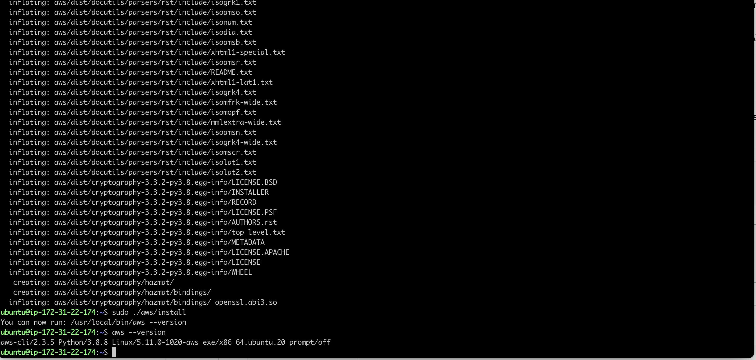

**Terraform**

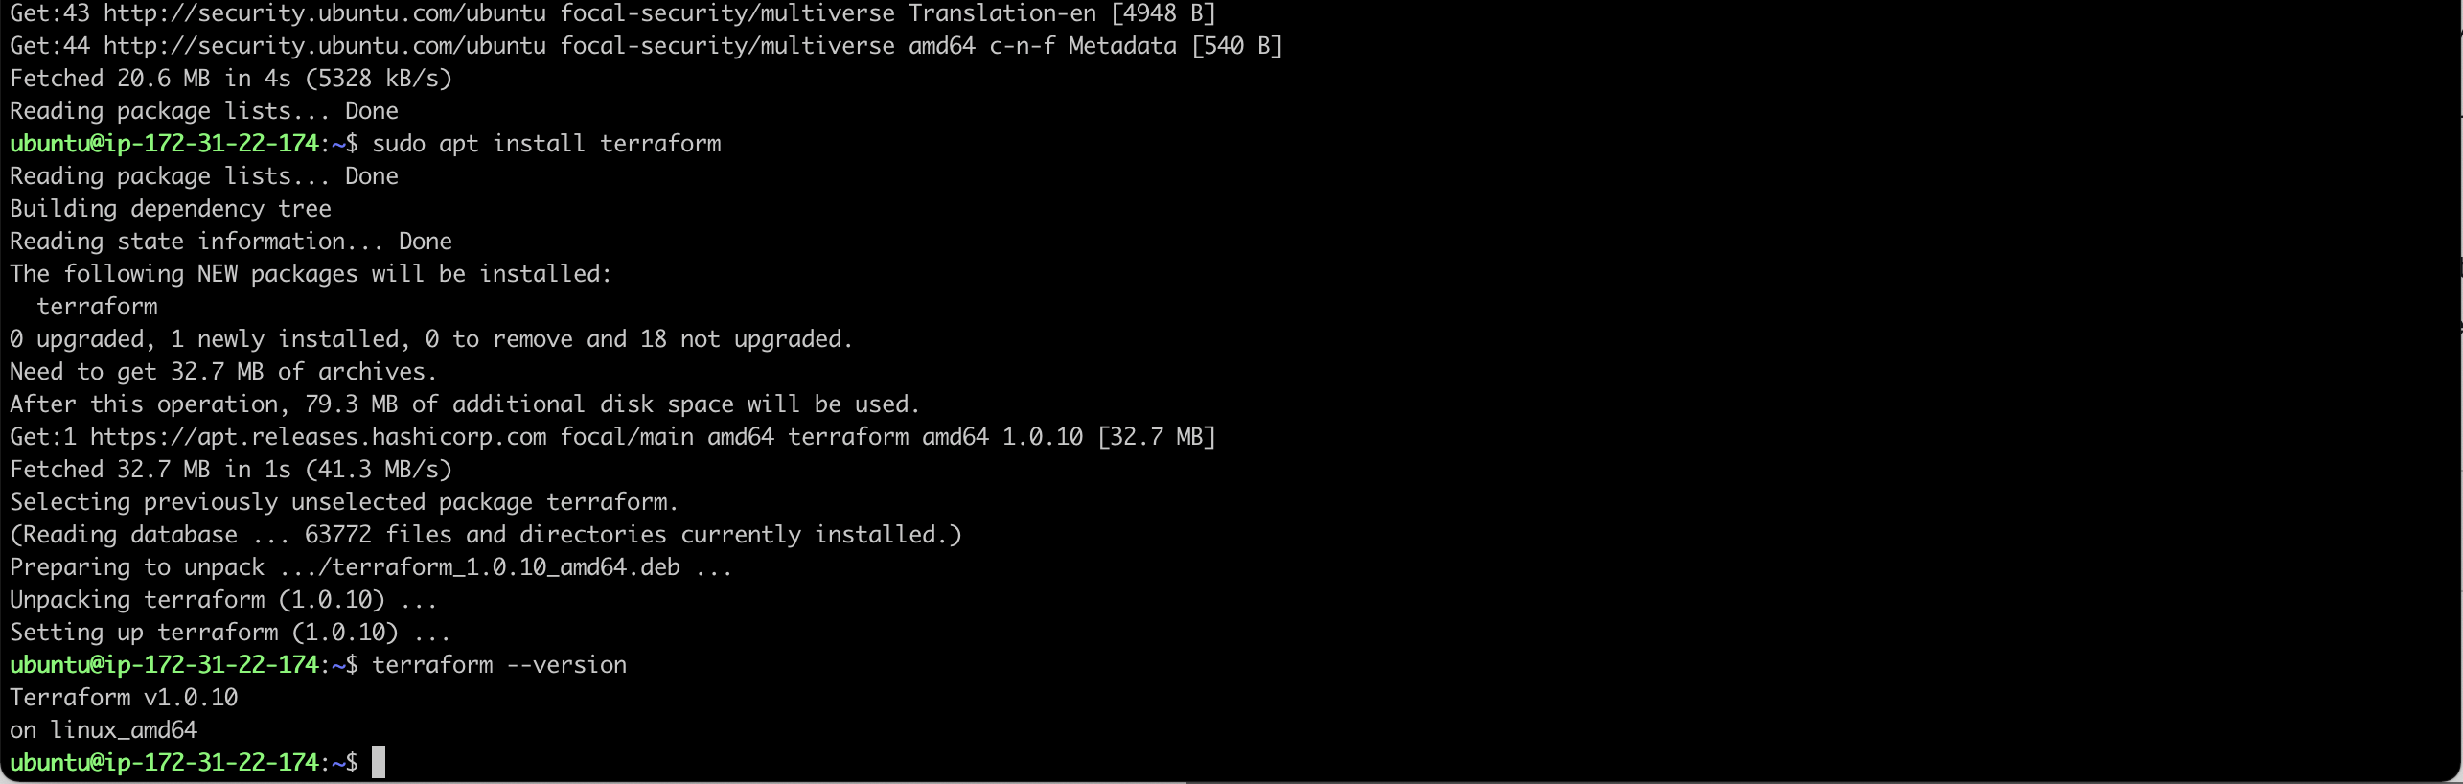

**IAM Access key**

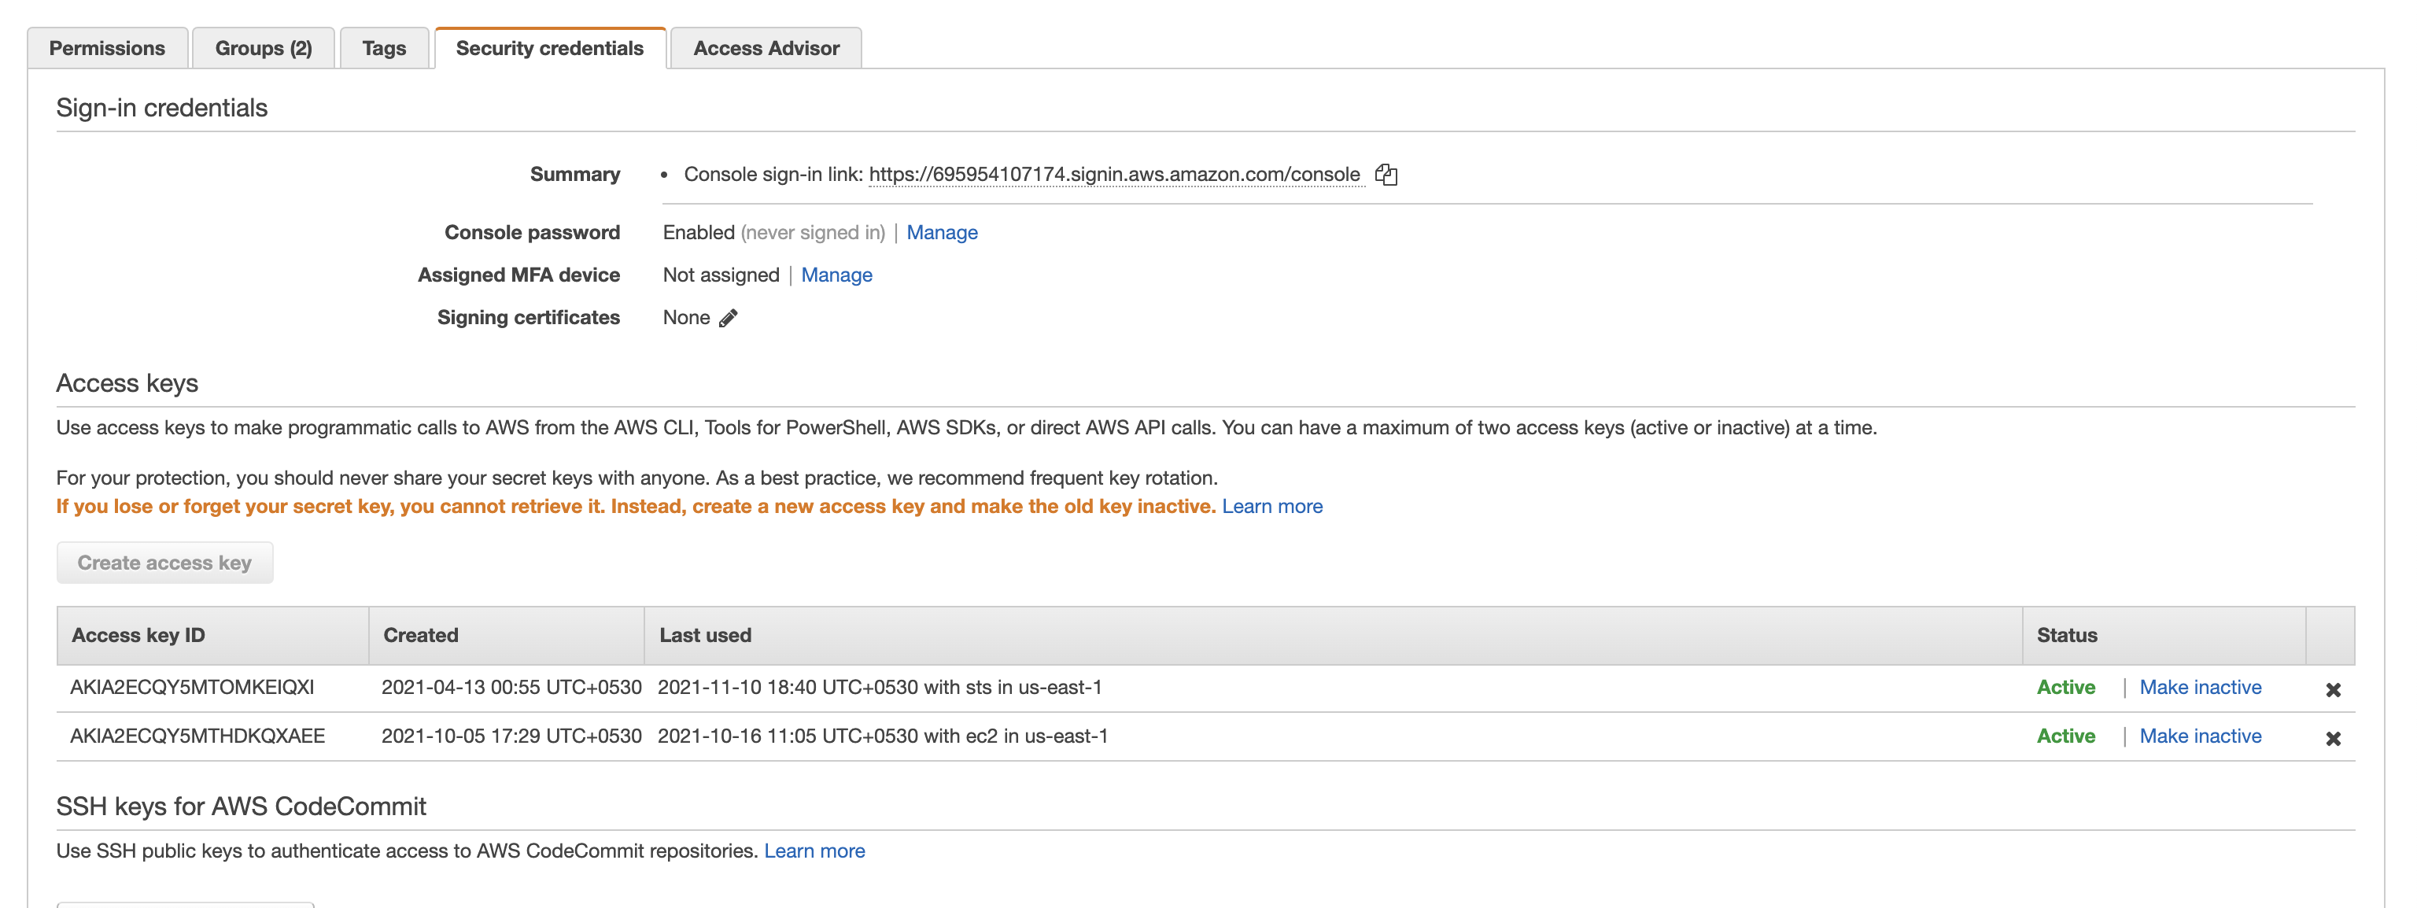

**Sample AWS command after configuration**

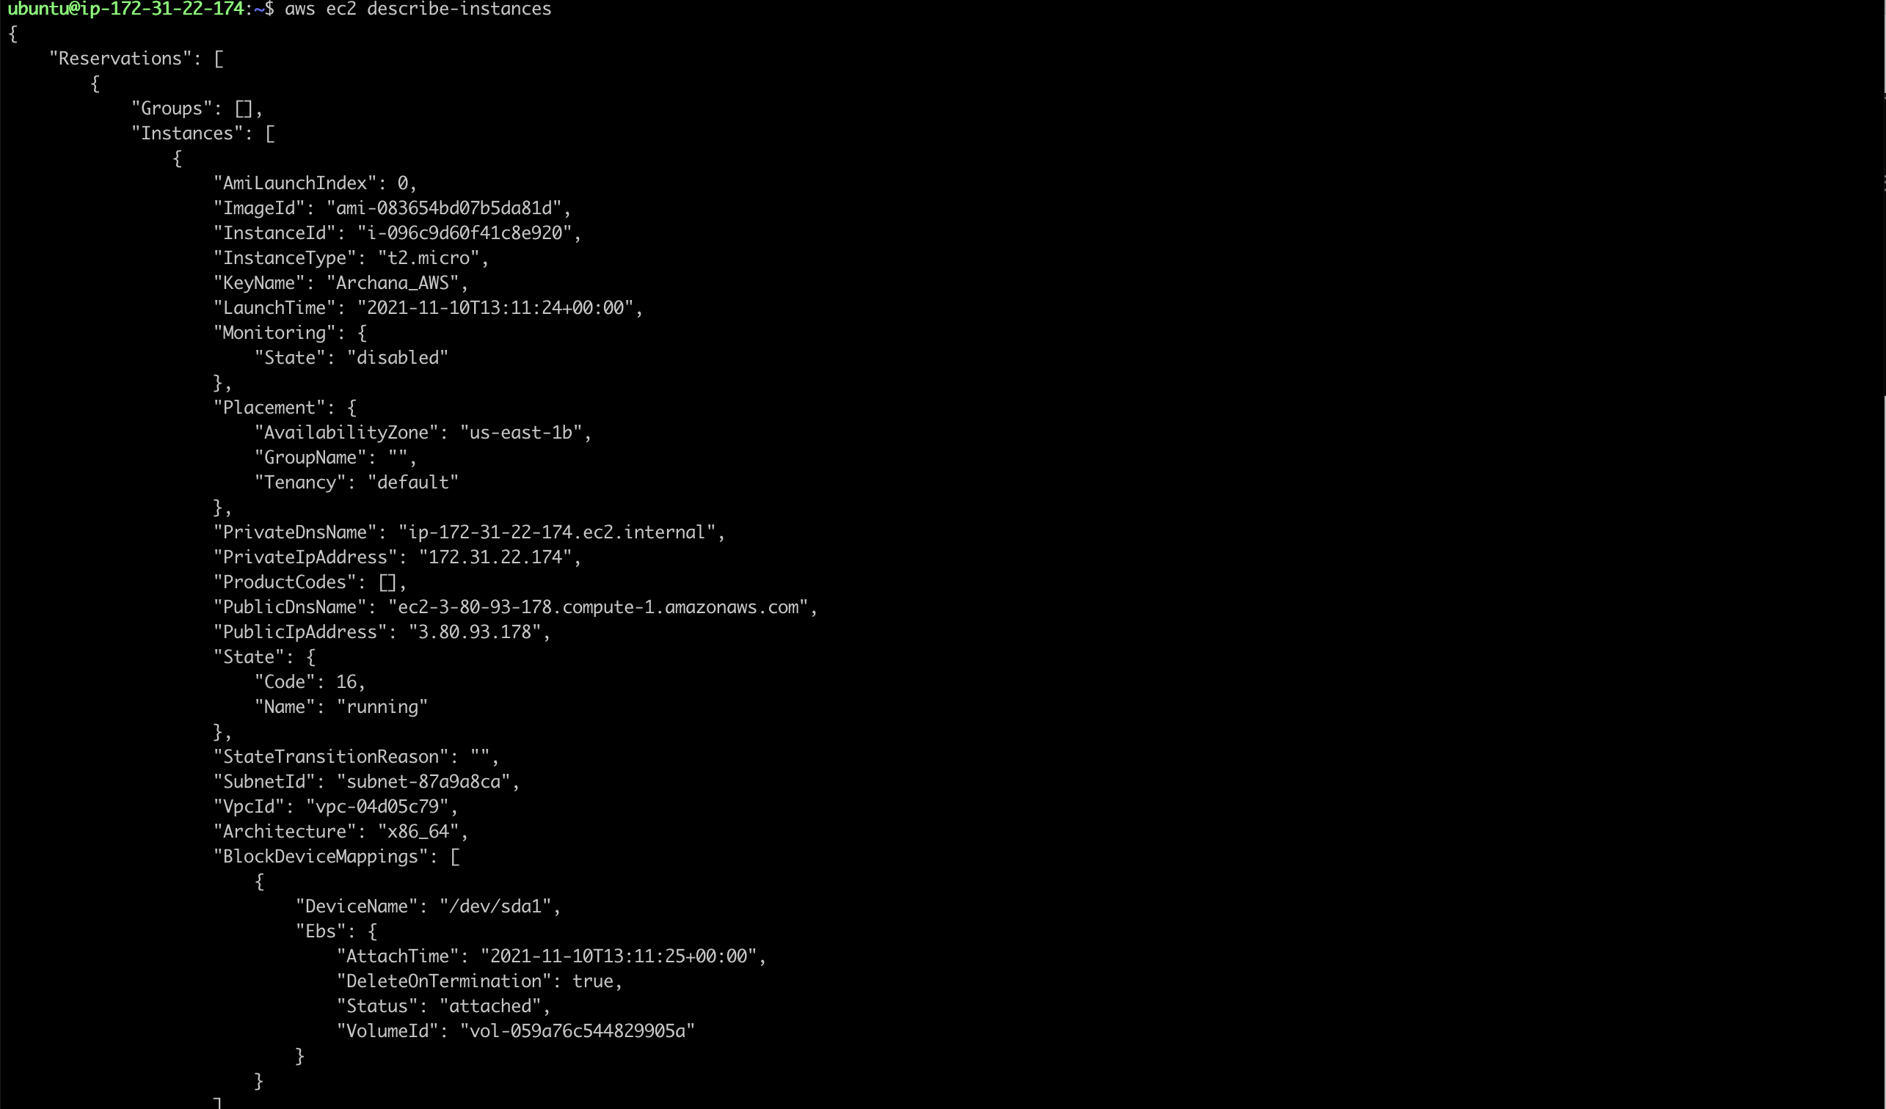

**EKSCTL Installation**

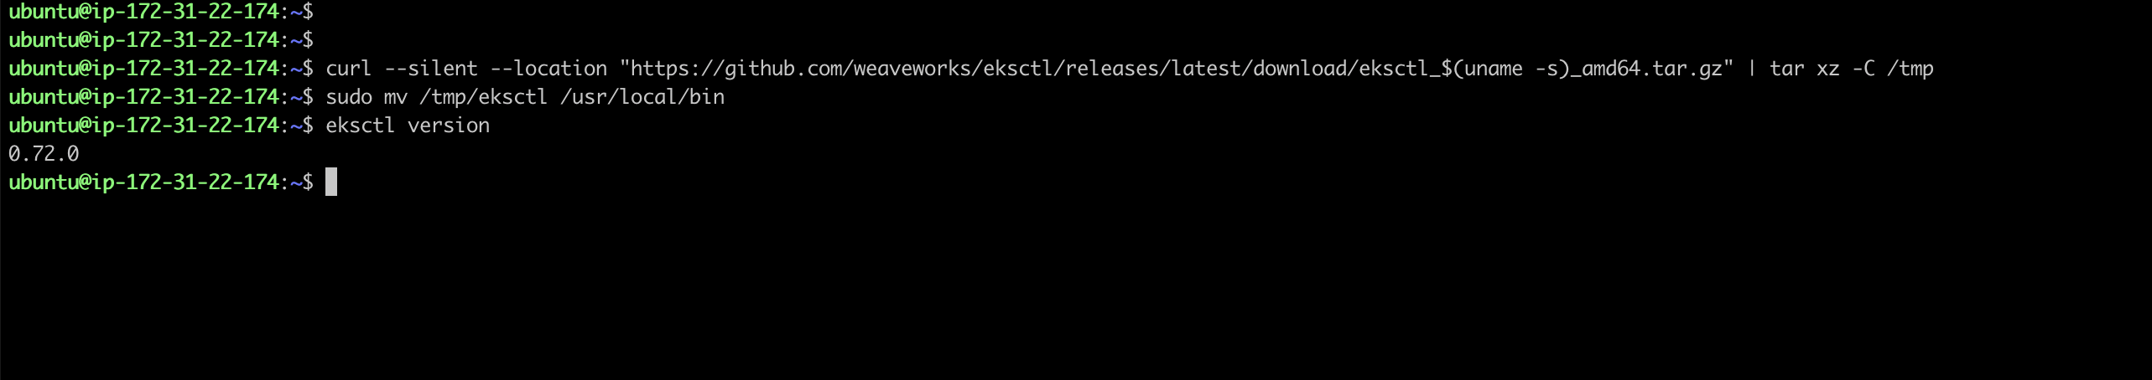

**KUBECTL installation**

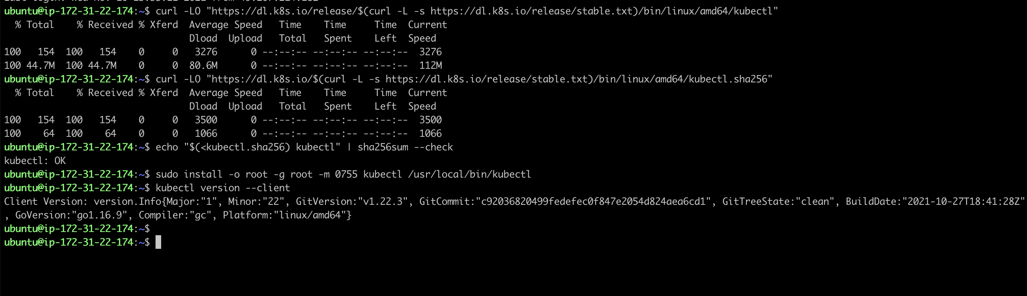

**Helm Installation**

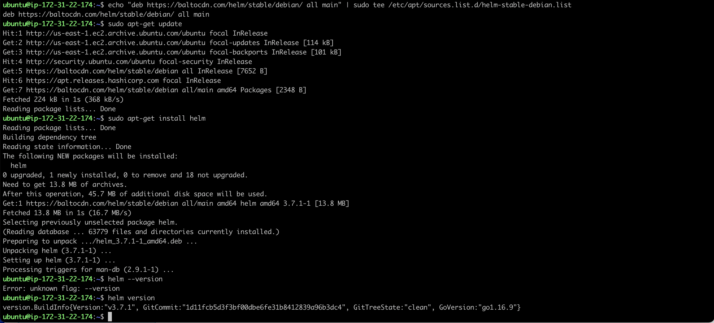

**Docker Installtation**

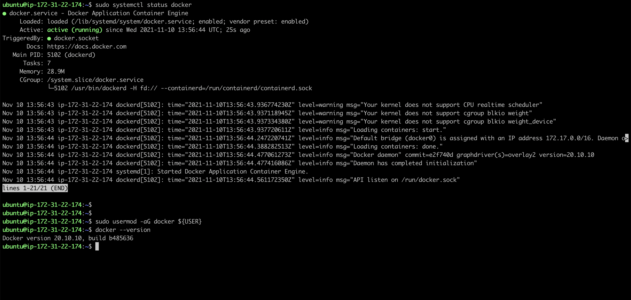

apache benchmark

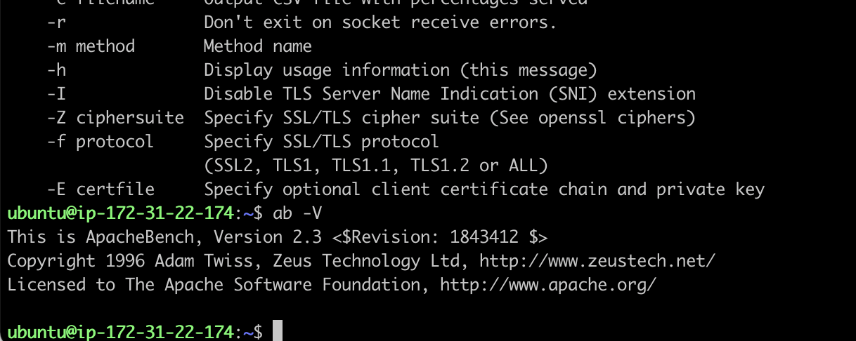

**Task1- Setup EKS Cluster**

**Task-1 - Subtask-1**

**AWS-CLI setup**



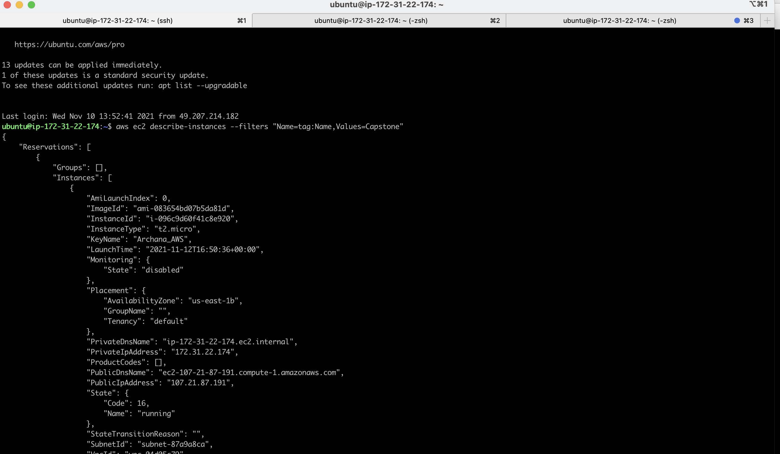

**Task1- Subtask-1- S3 bucket to state management**

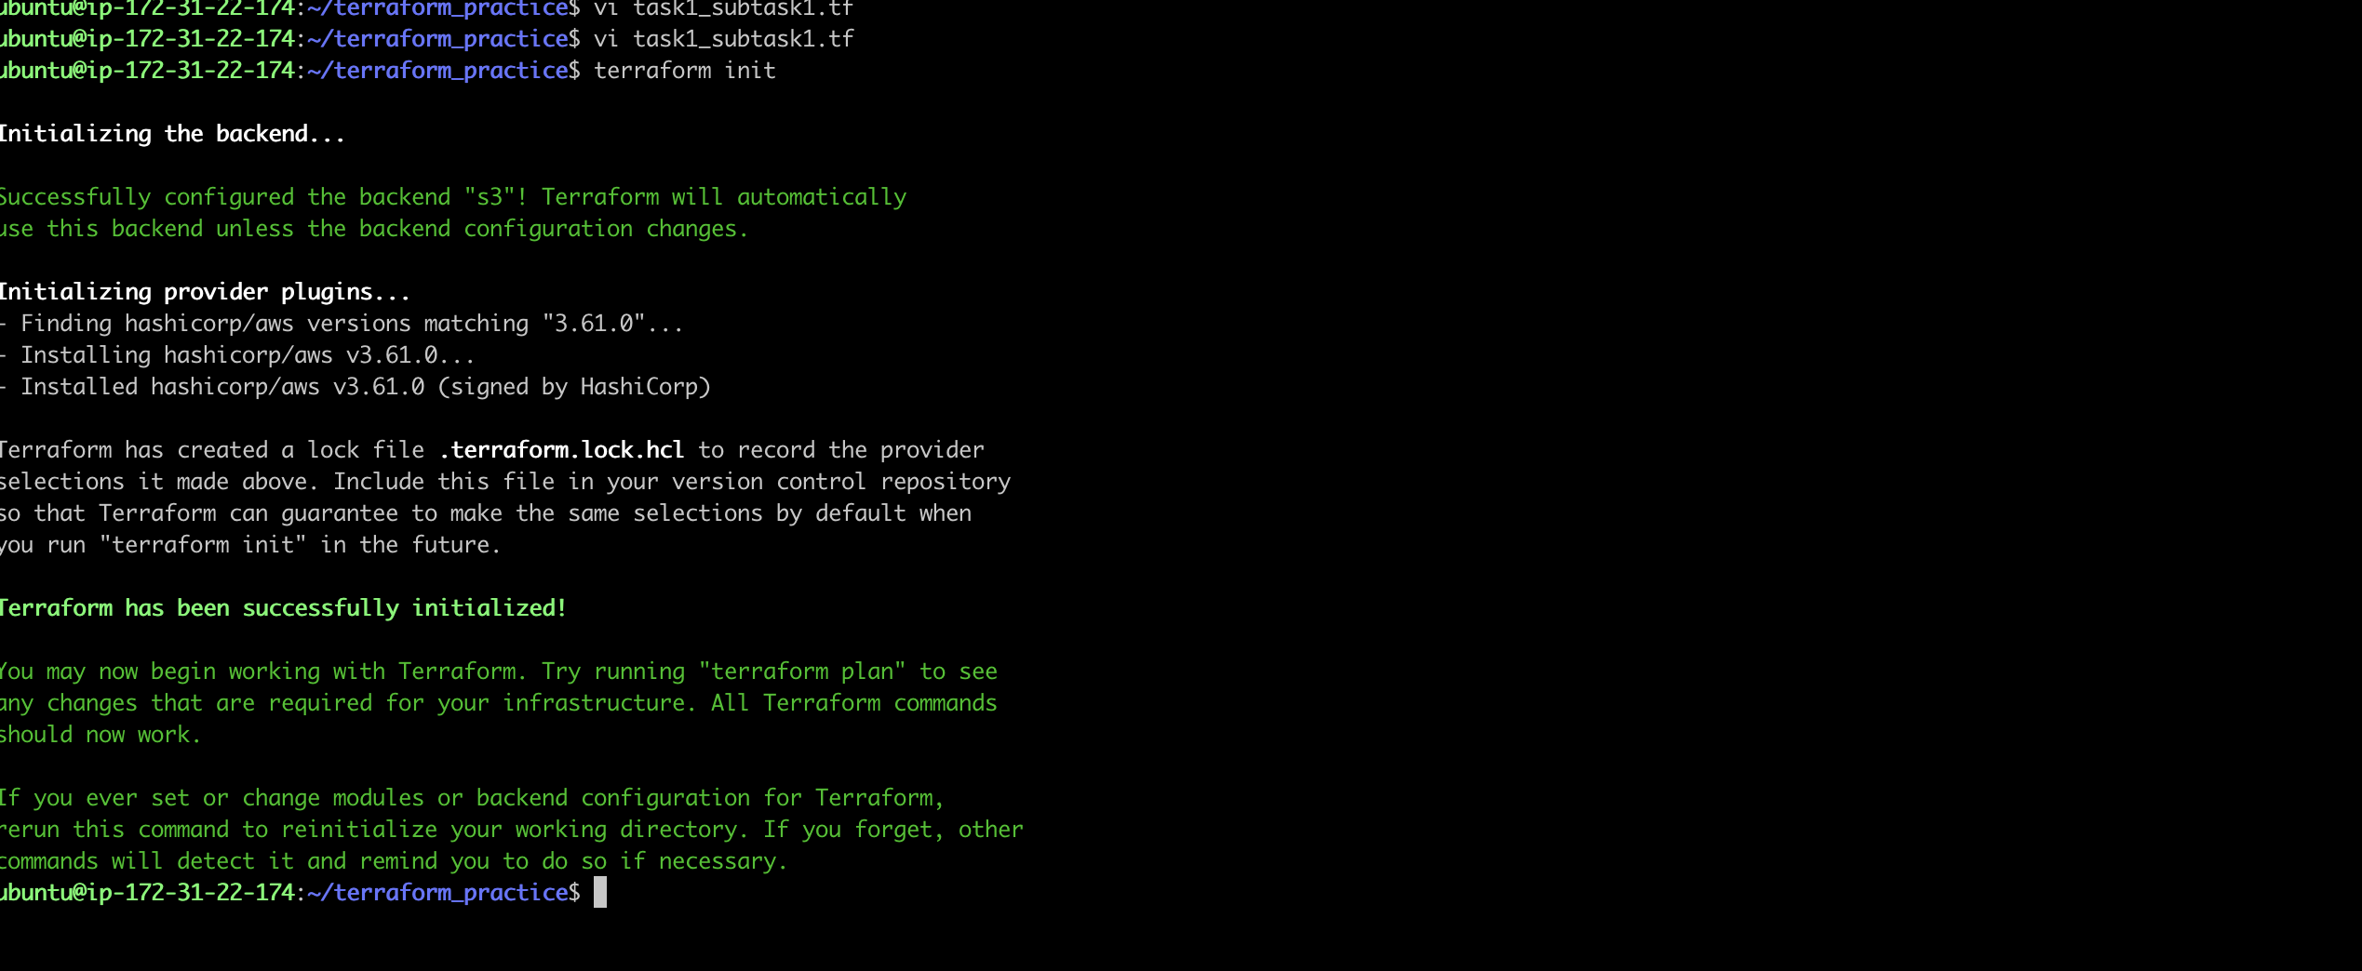

**Task1- Subtask2 – VPC Creation**

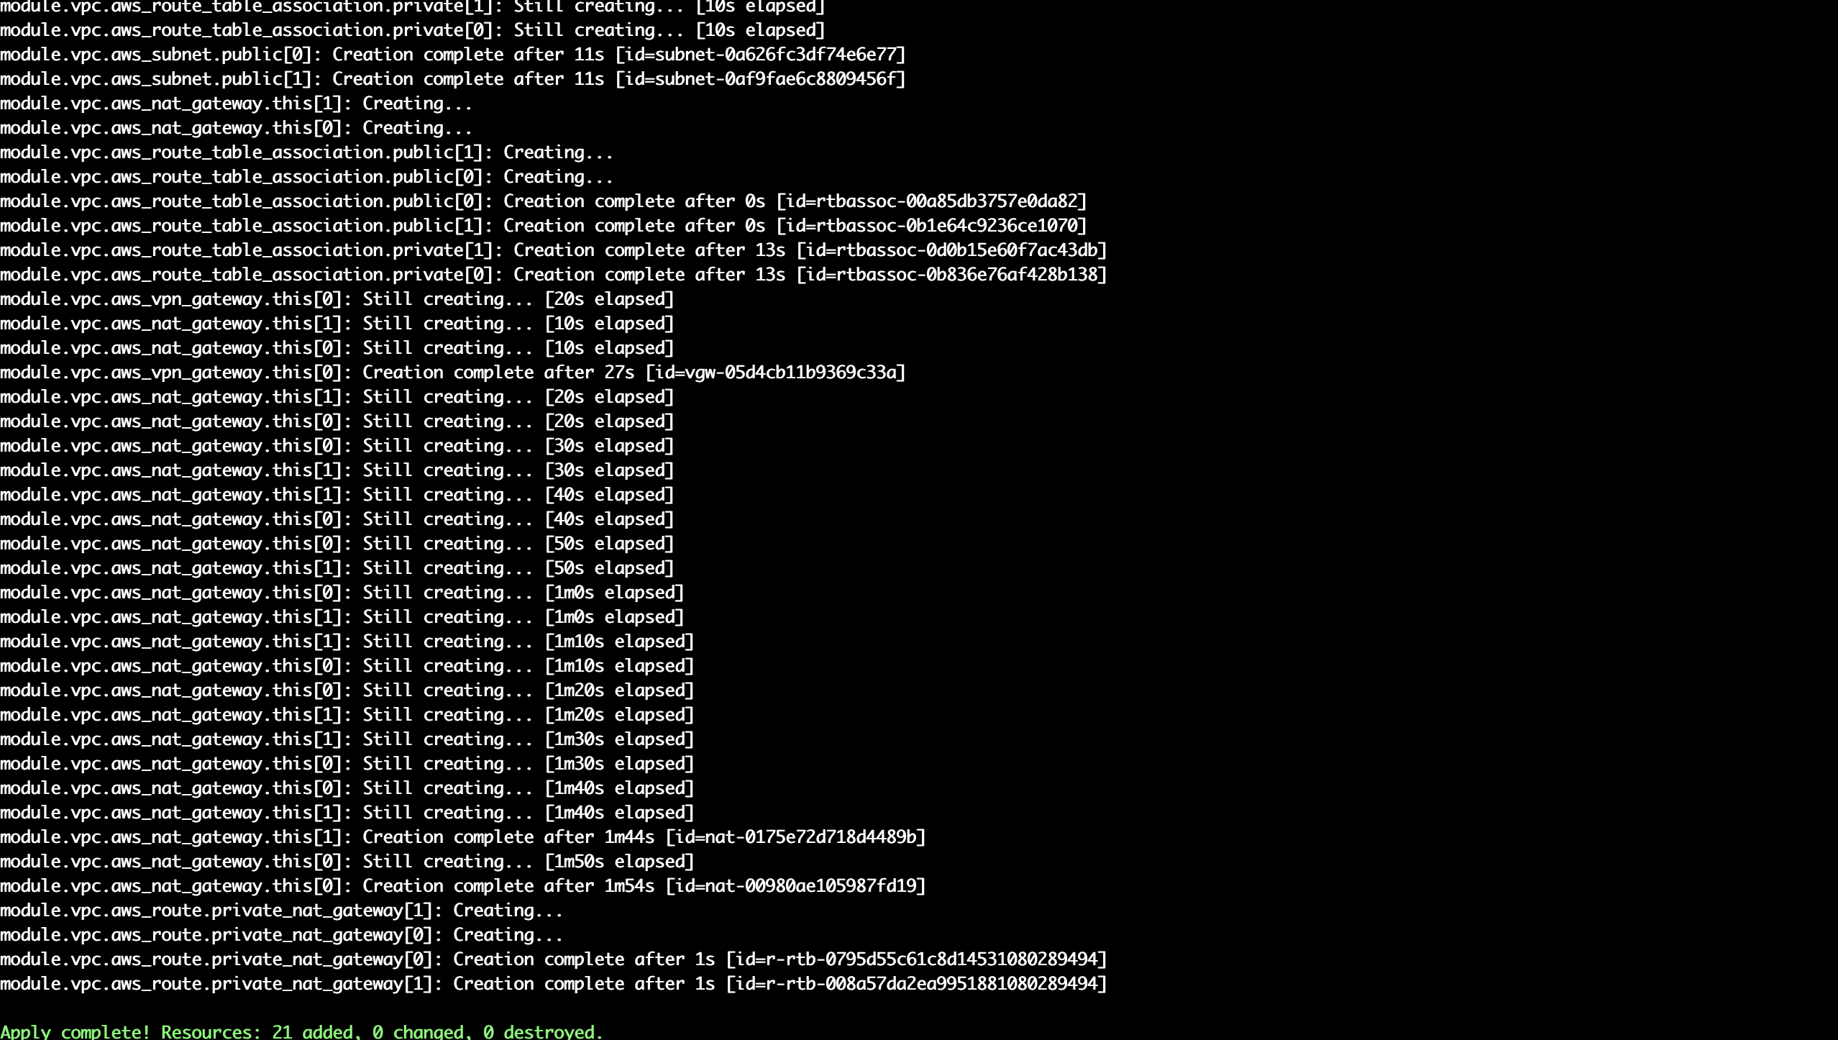

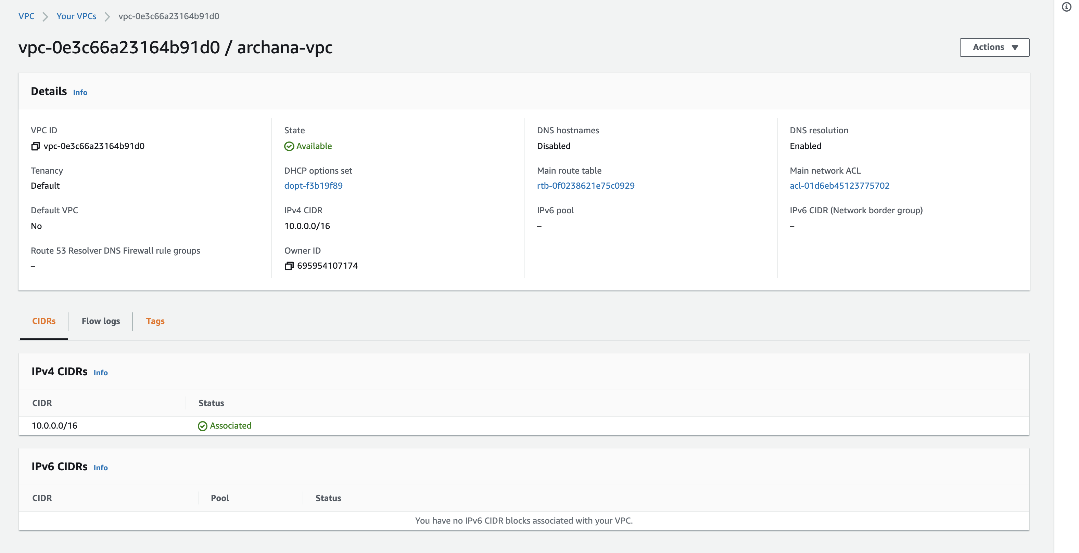

**Subnet tagging**

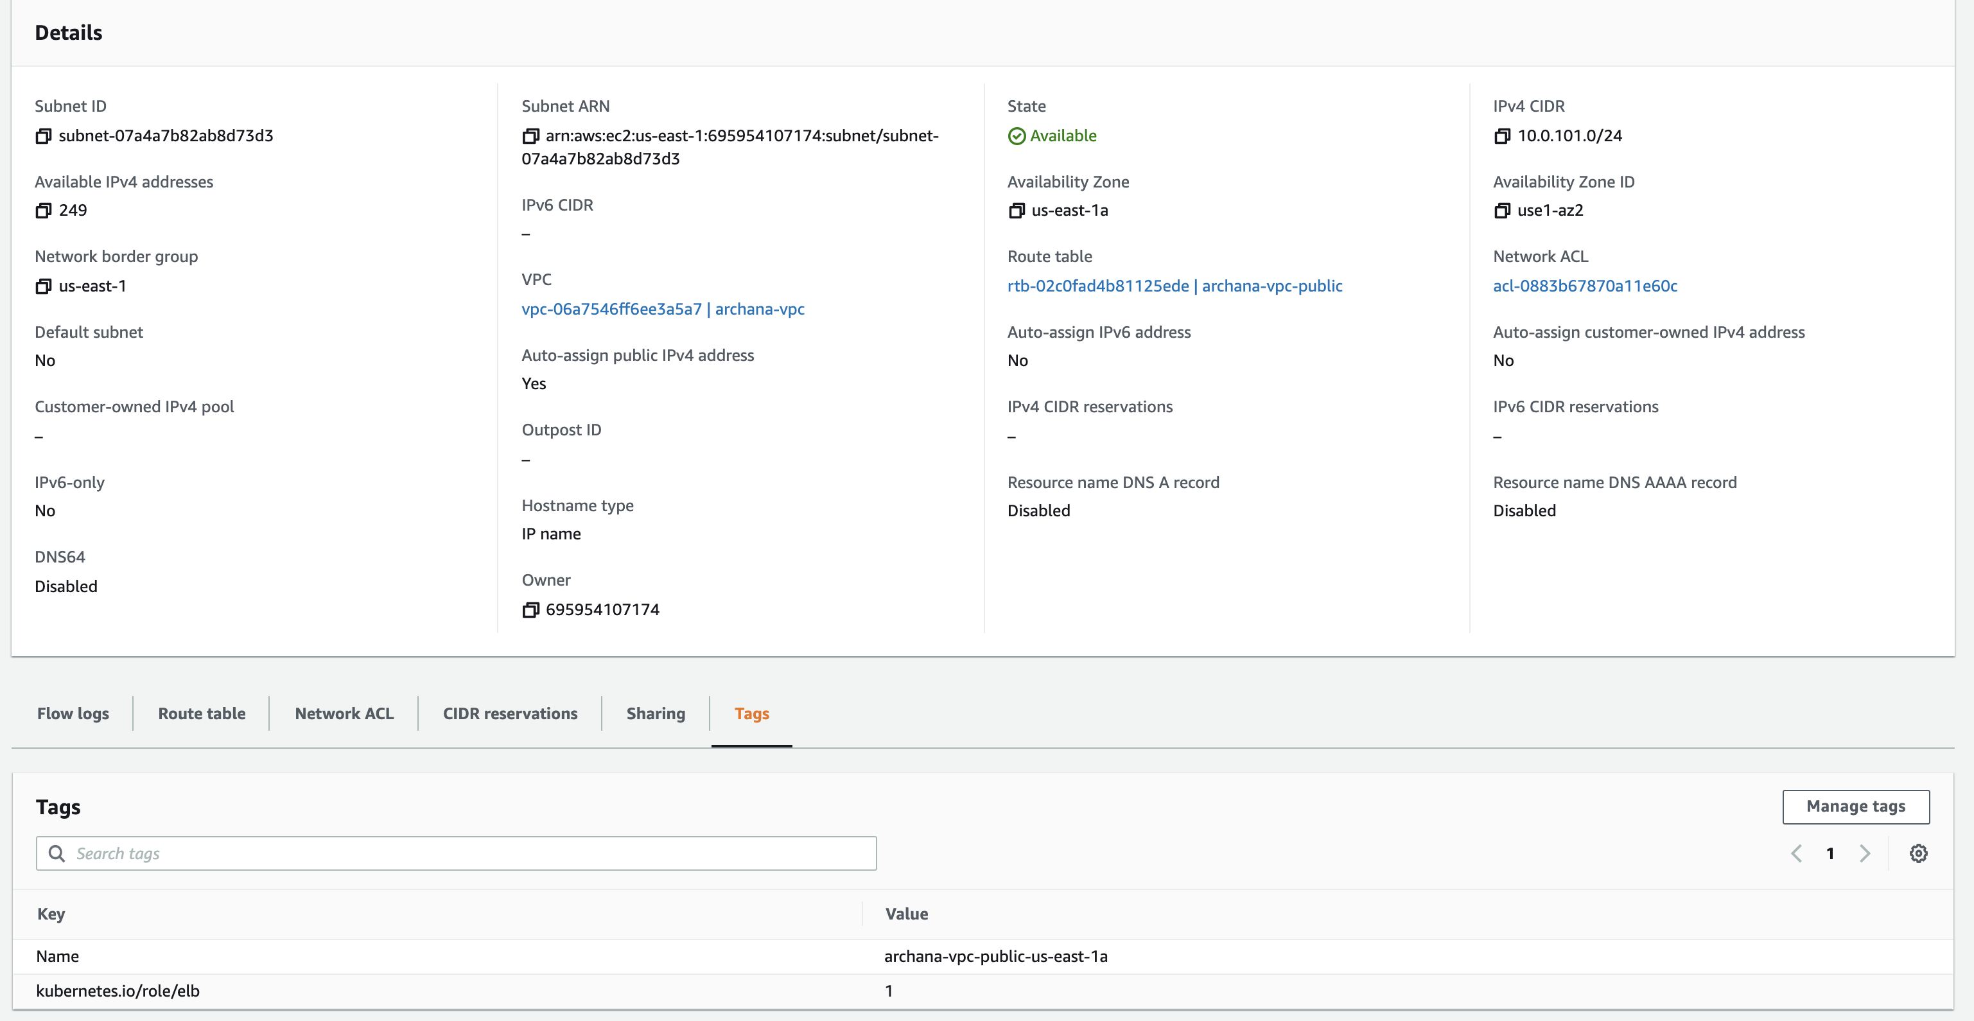

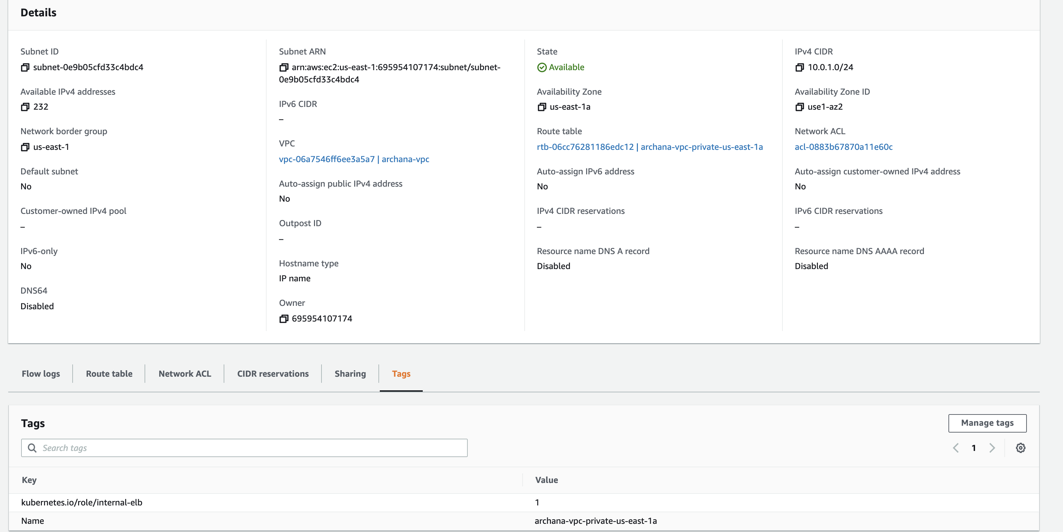

**Task1-Subtask3 – Creation of EKS Cluster (using above VPC)**

**Vpc ids & subnet ids are mapped accordintly in conf yaml**

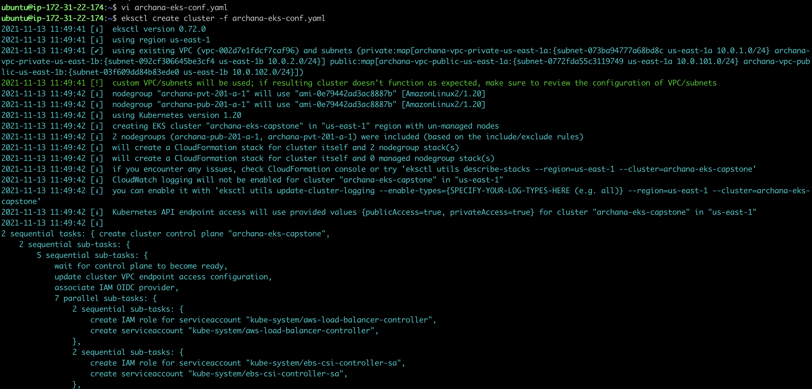

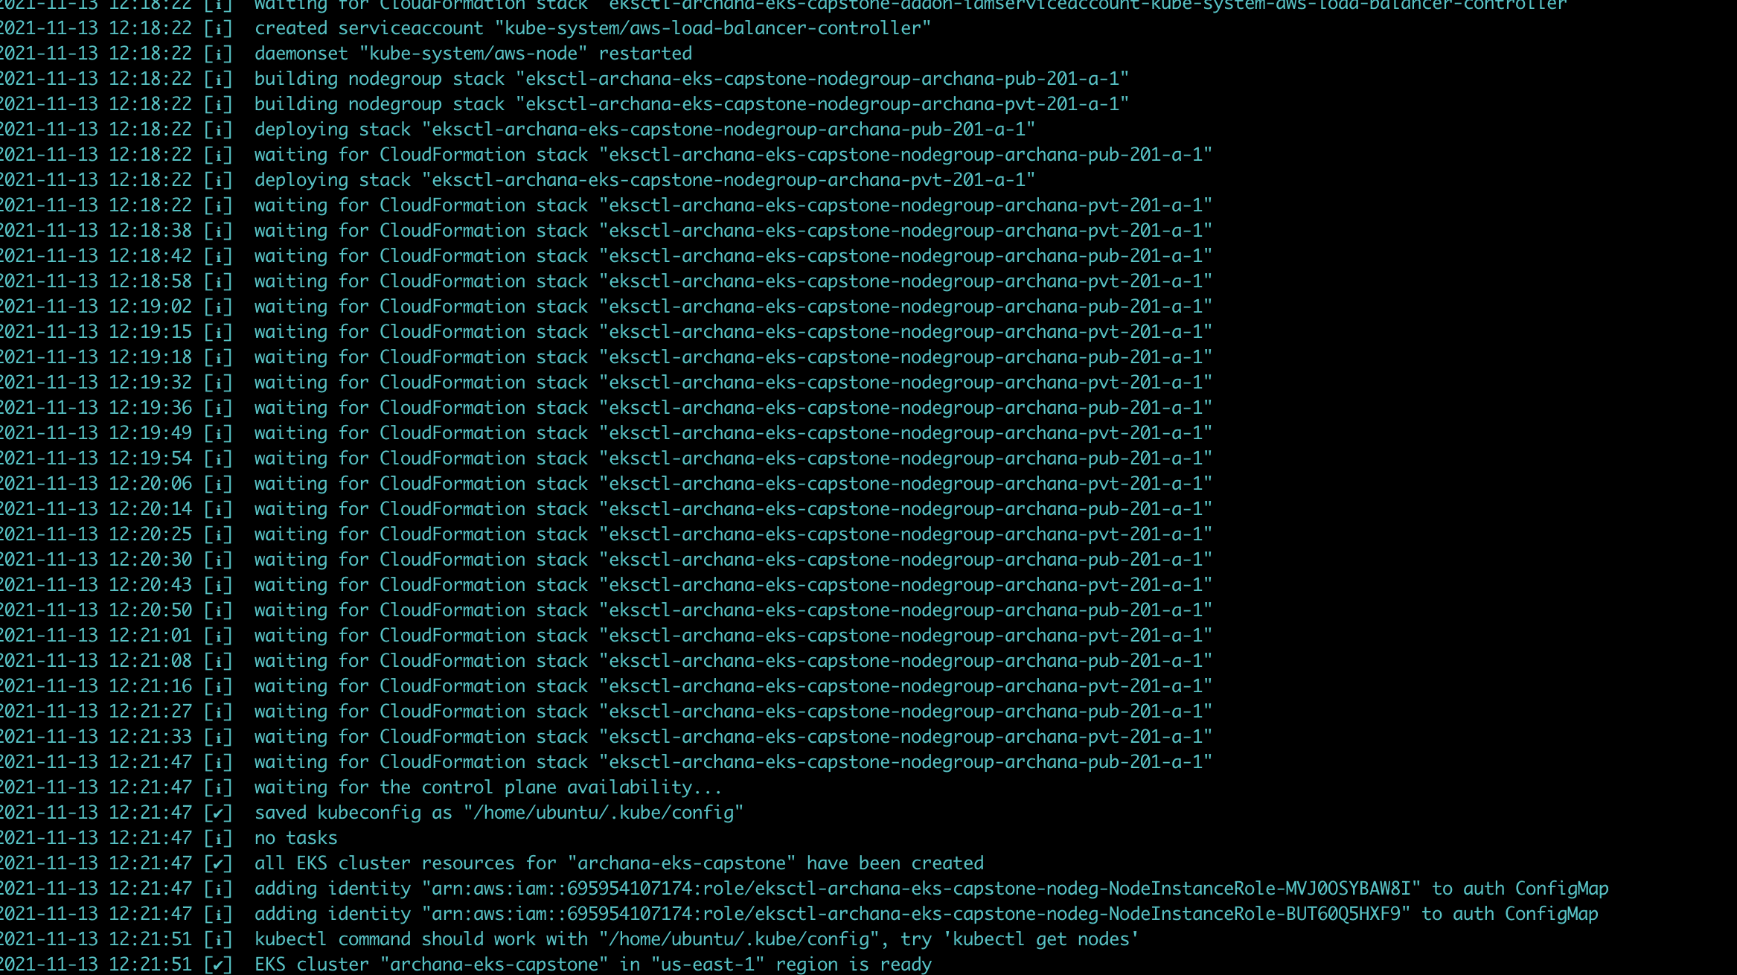

**Cloudformation**

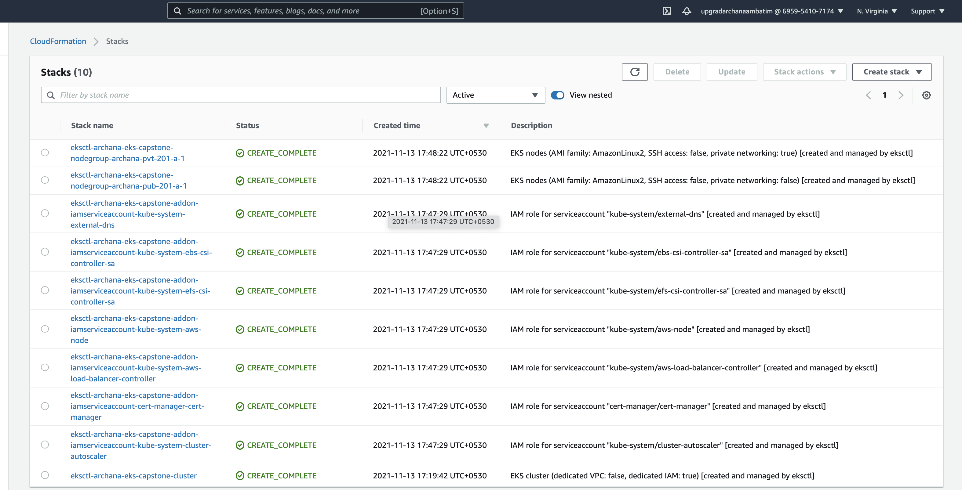

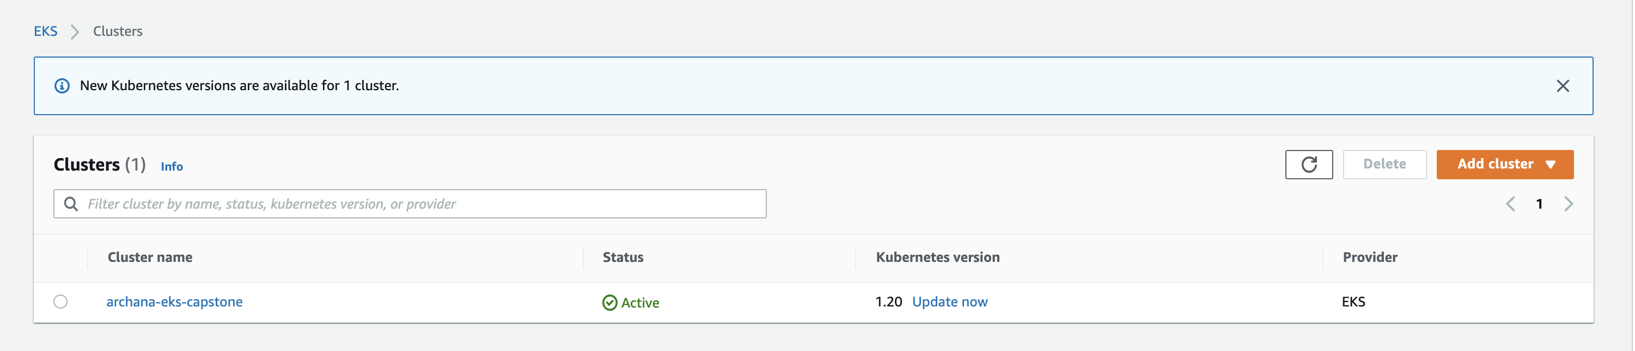

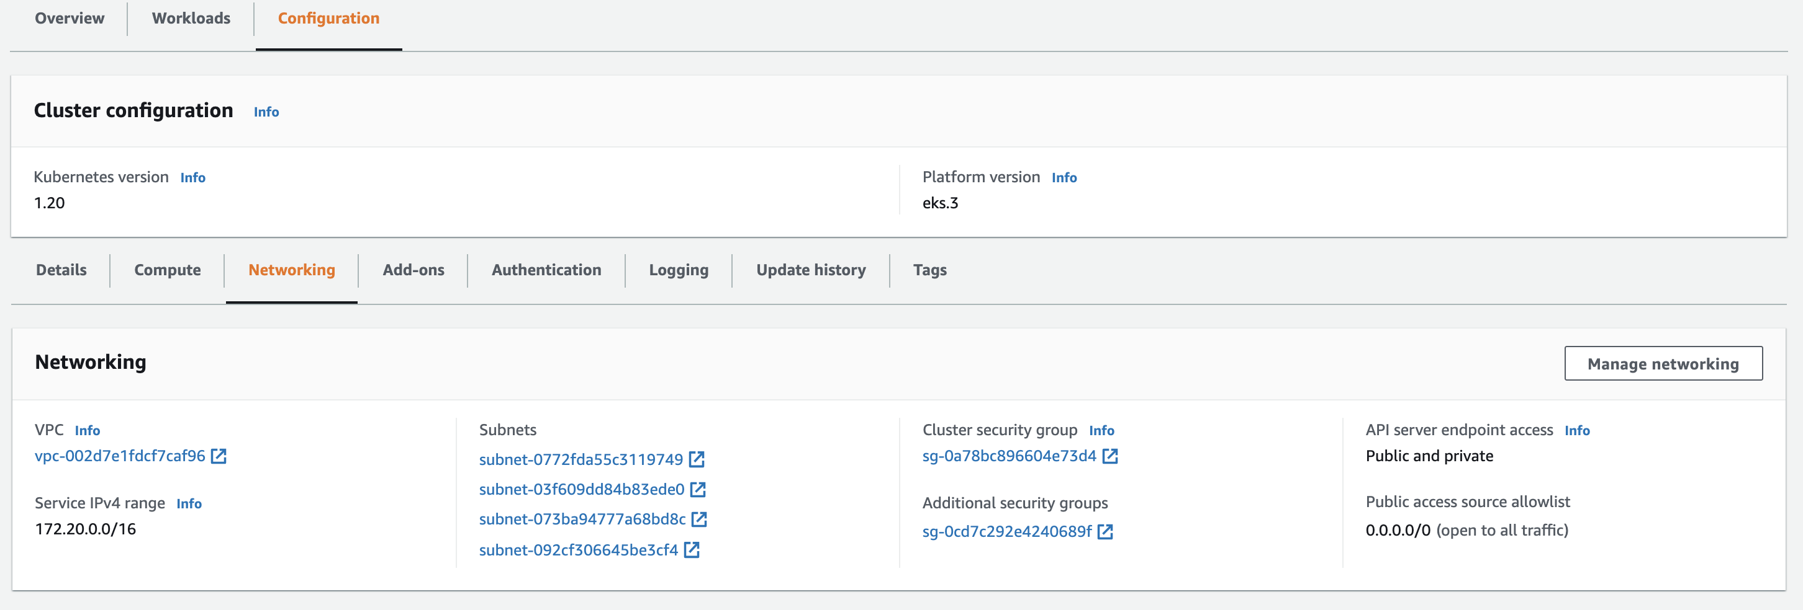

**Eksctl cluster and node groups**

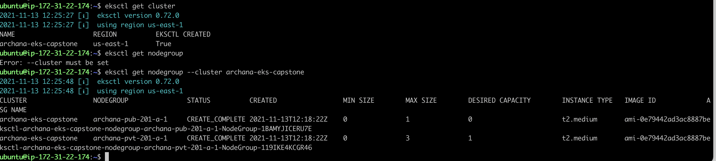

**Kubectl (after EKS Cluster setup)**

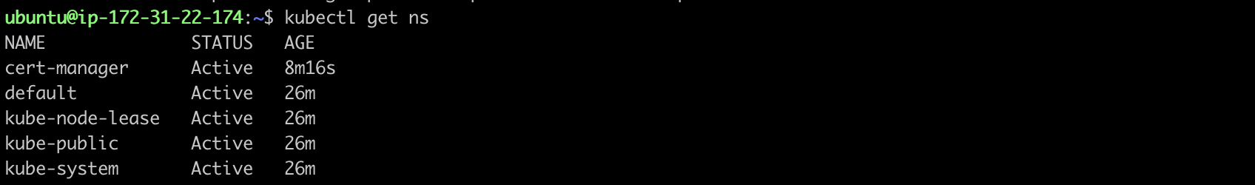

**Task1-subtask4 – AWS load balancer controller v2 addon**

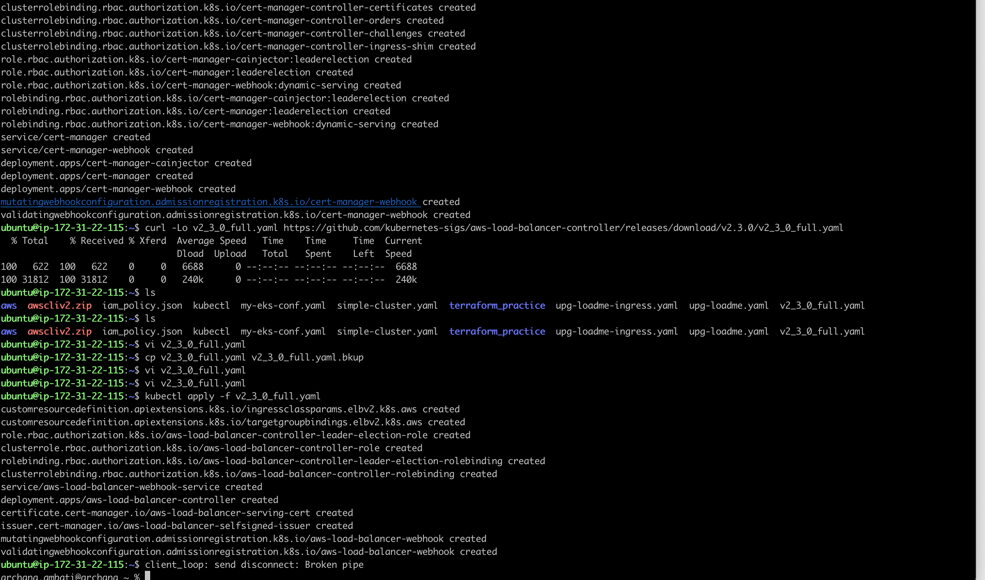

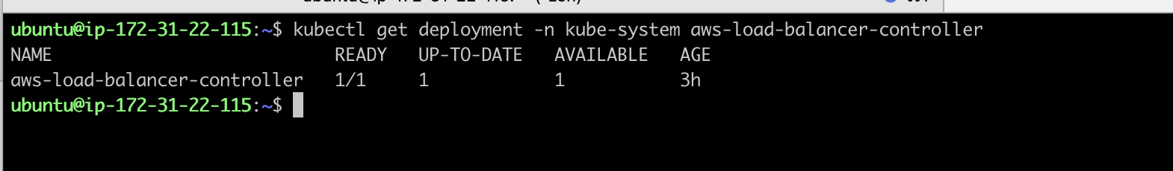

**Kubernetes-metrics-server**

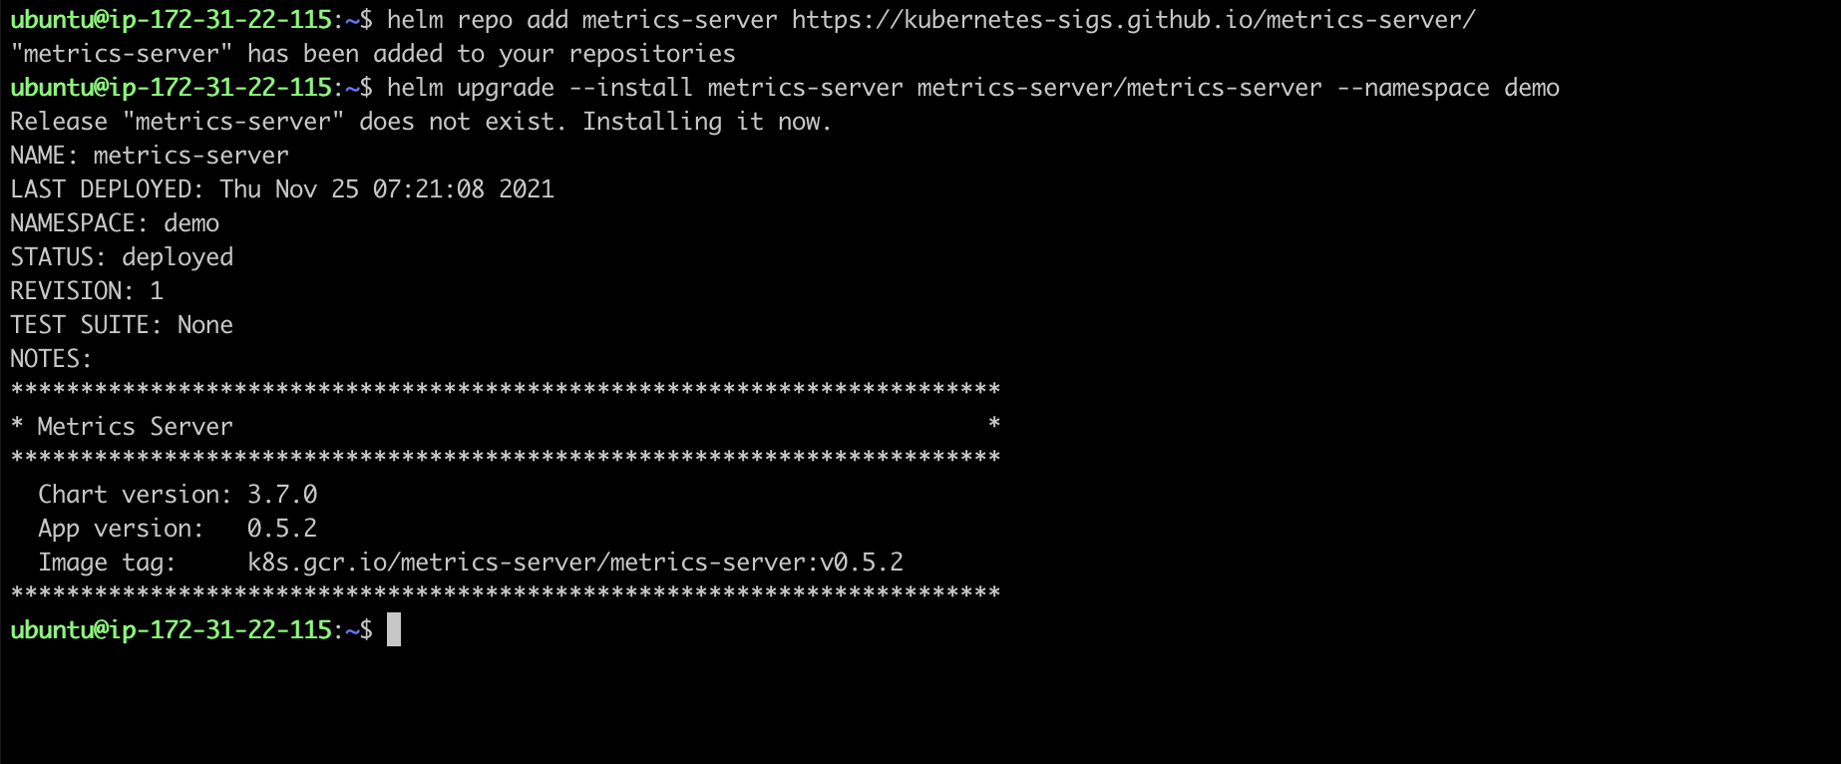

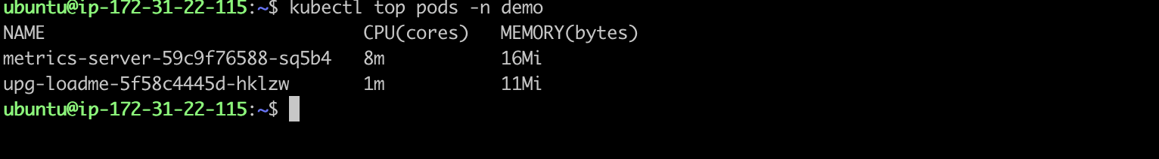

**Cluster Auto scaler**

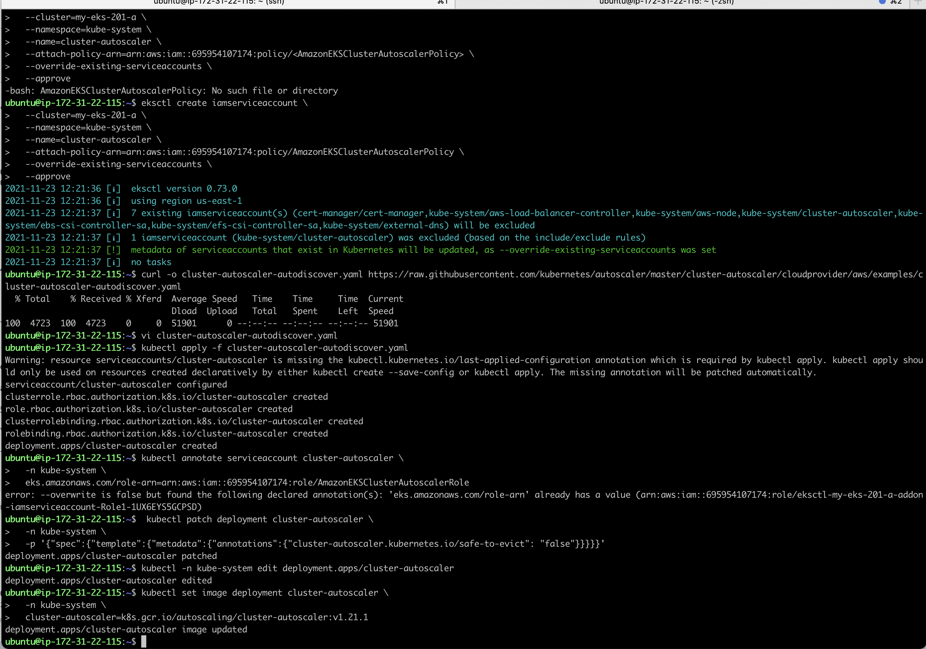

**Auto scaler logs**

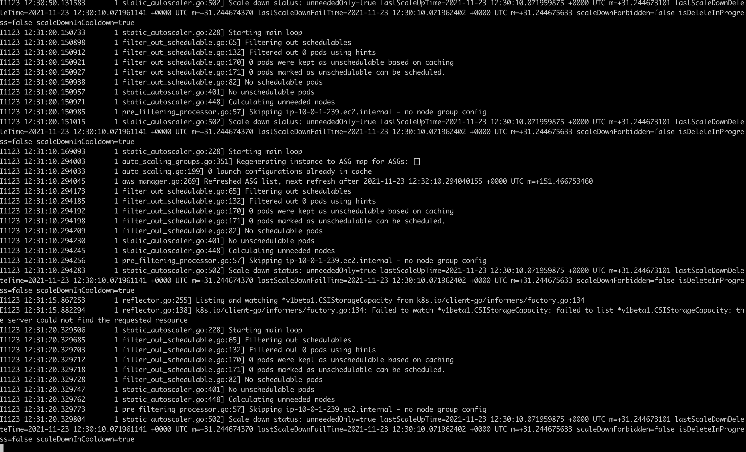

**Task2- Deployment of sample application**

**Task2-Subask-1 : ECR Repository**

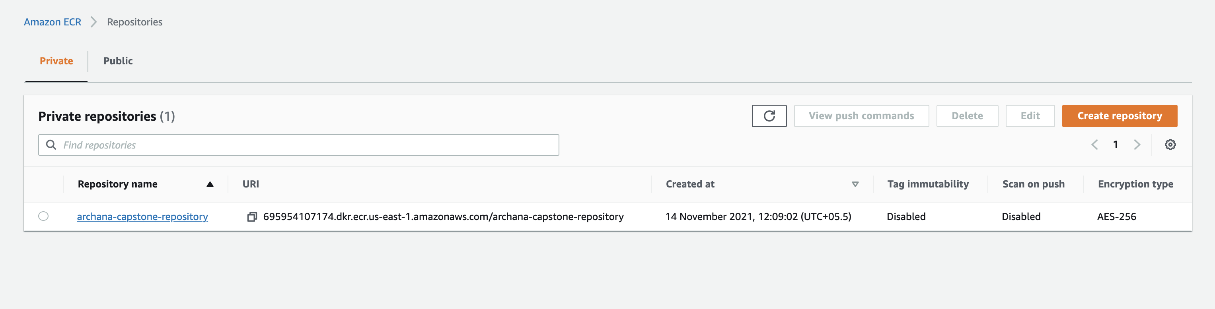

**Task2-Subtask-1: Docker build in local machine**

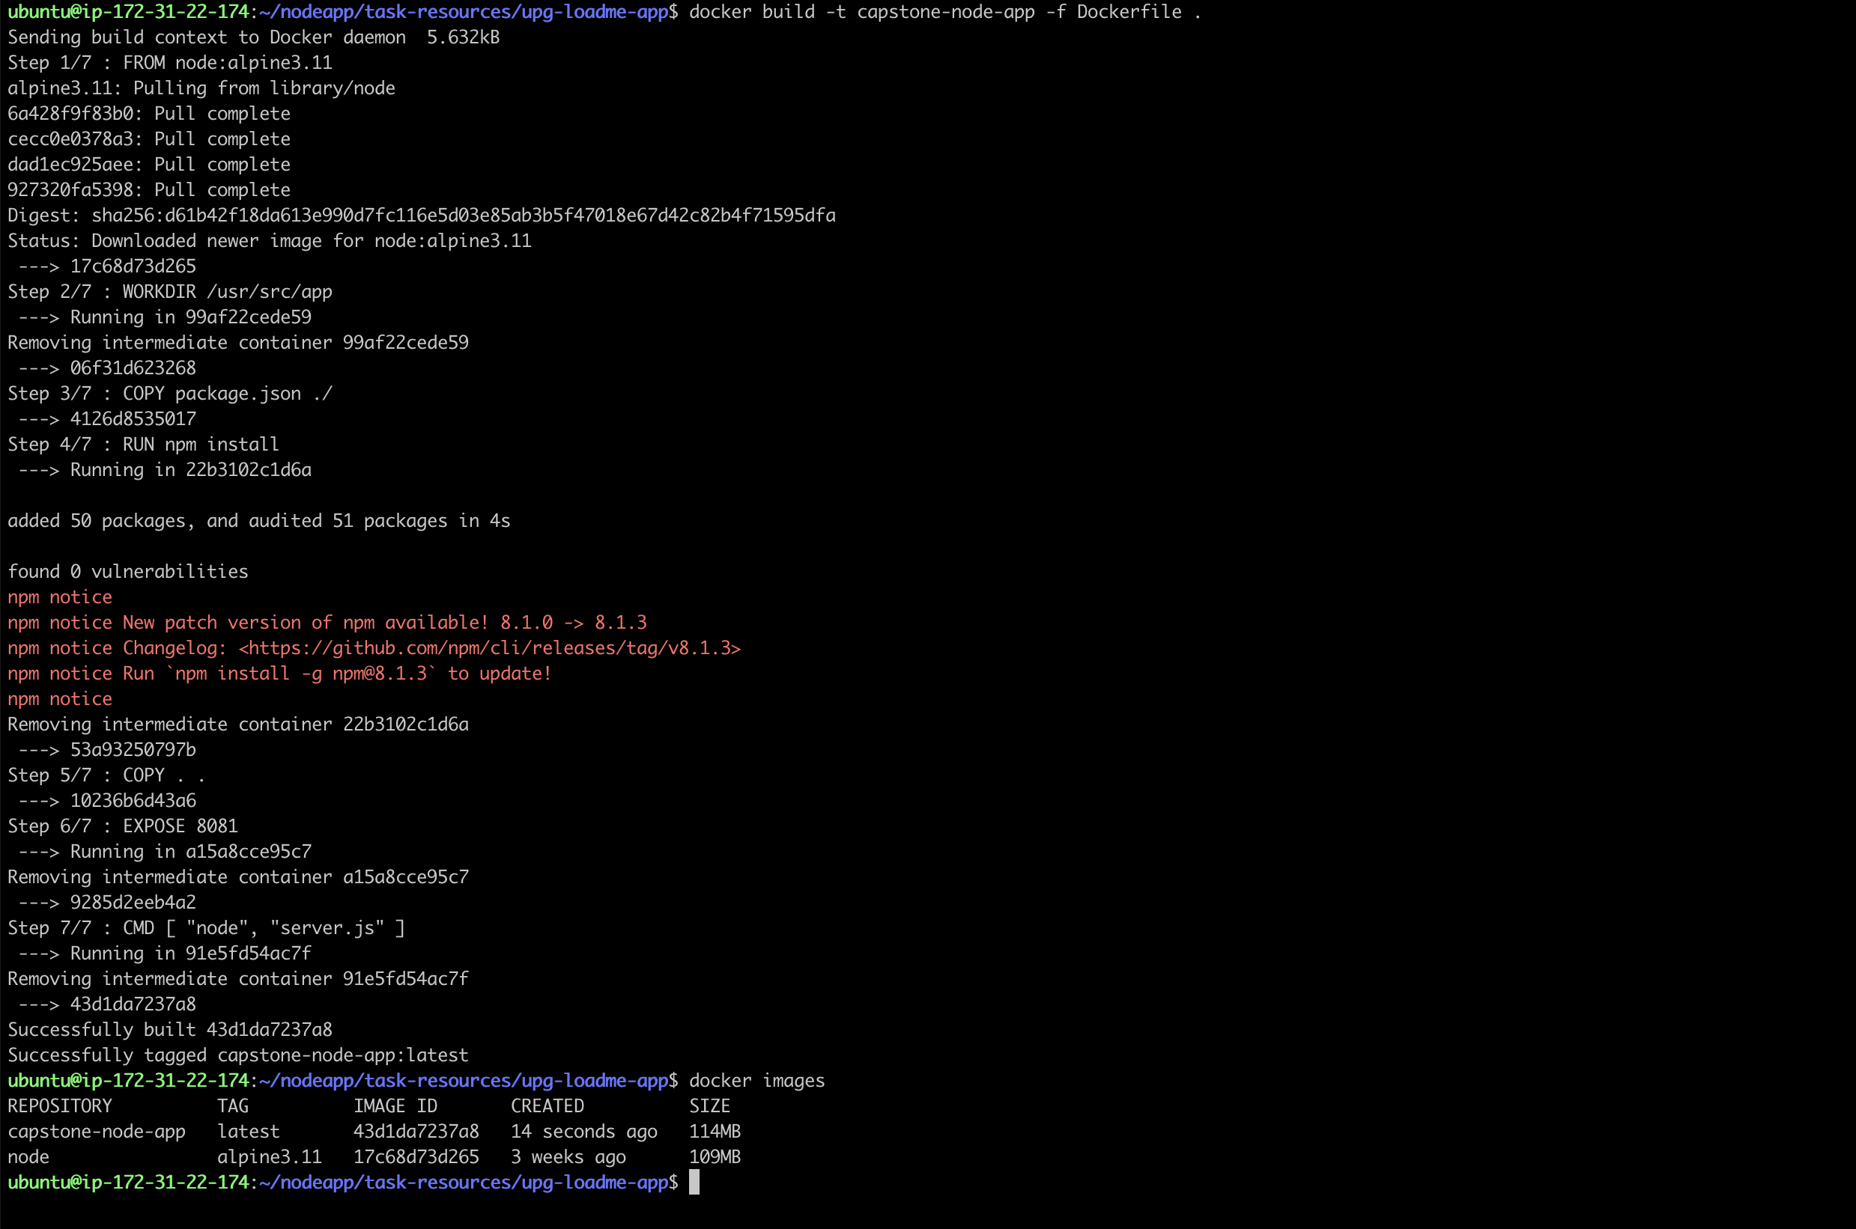

**Task2-Subtask-1 : Docker build and run in local machine**

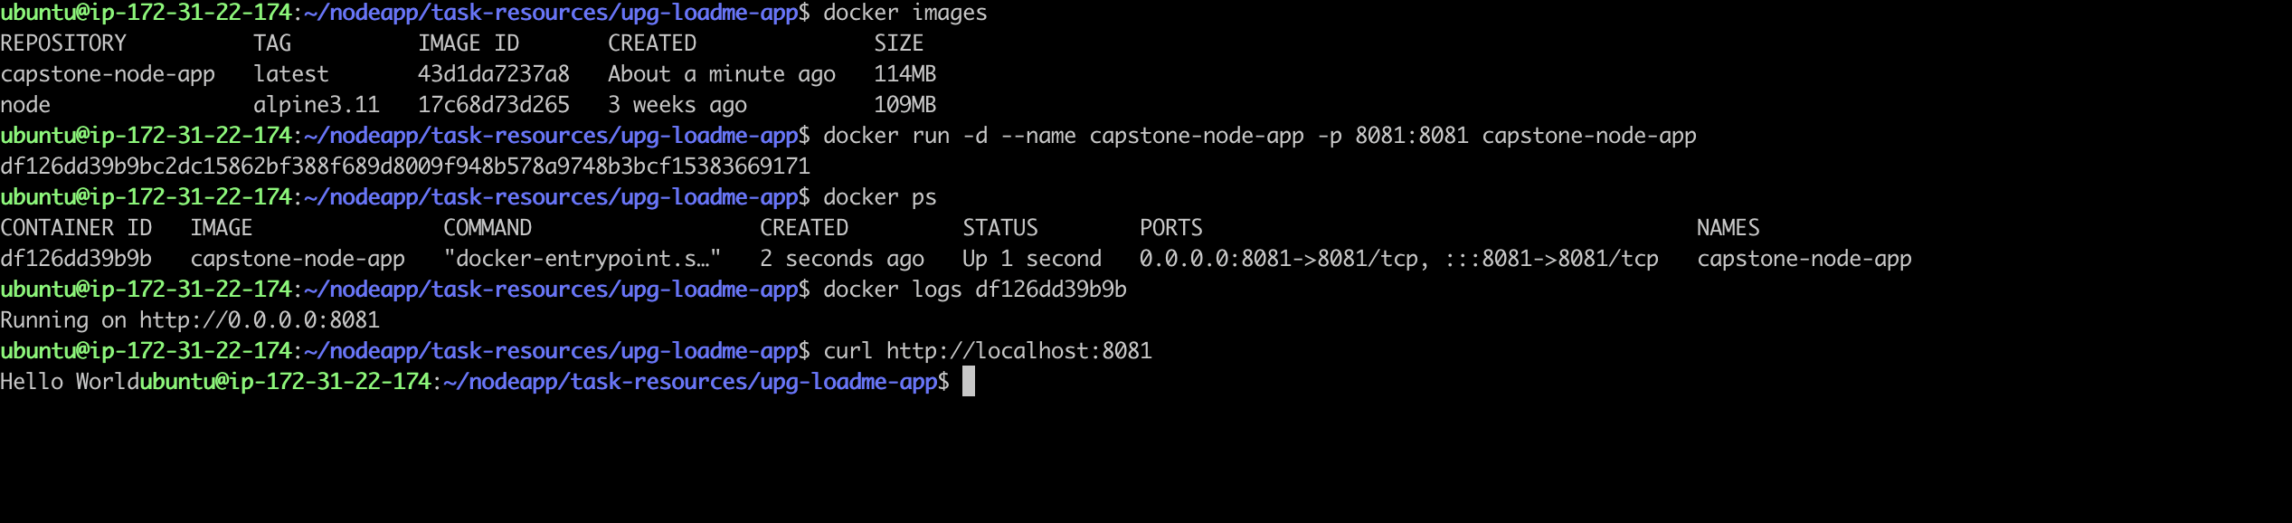

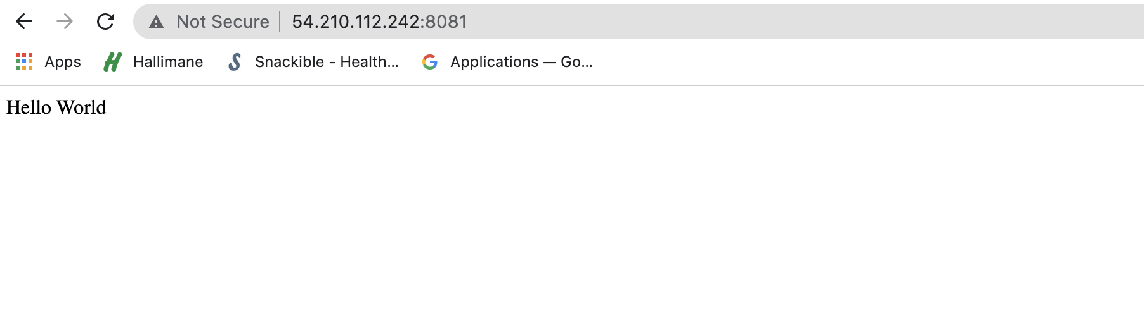

**Task2-Subtask-1 : Tag & Push Docker image to ECR Repo**

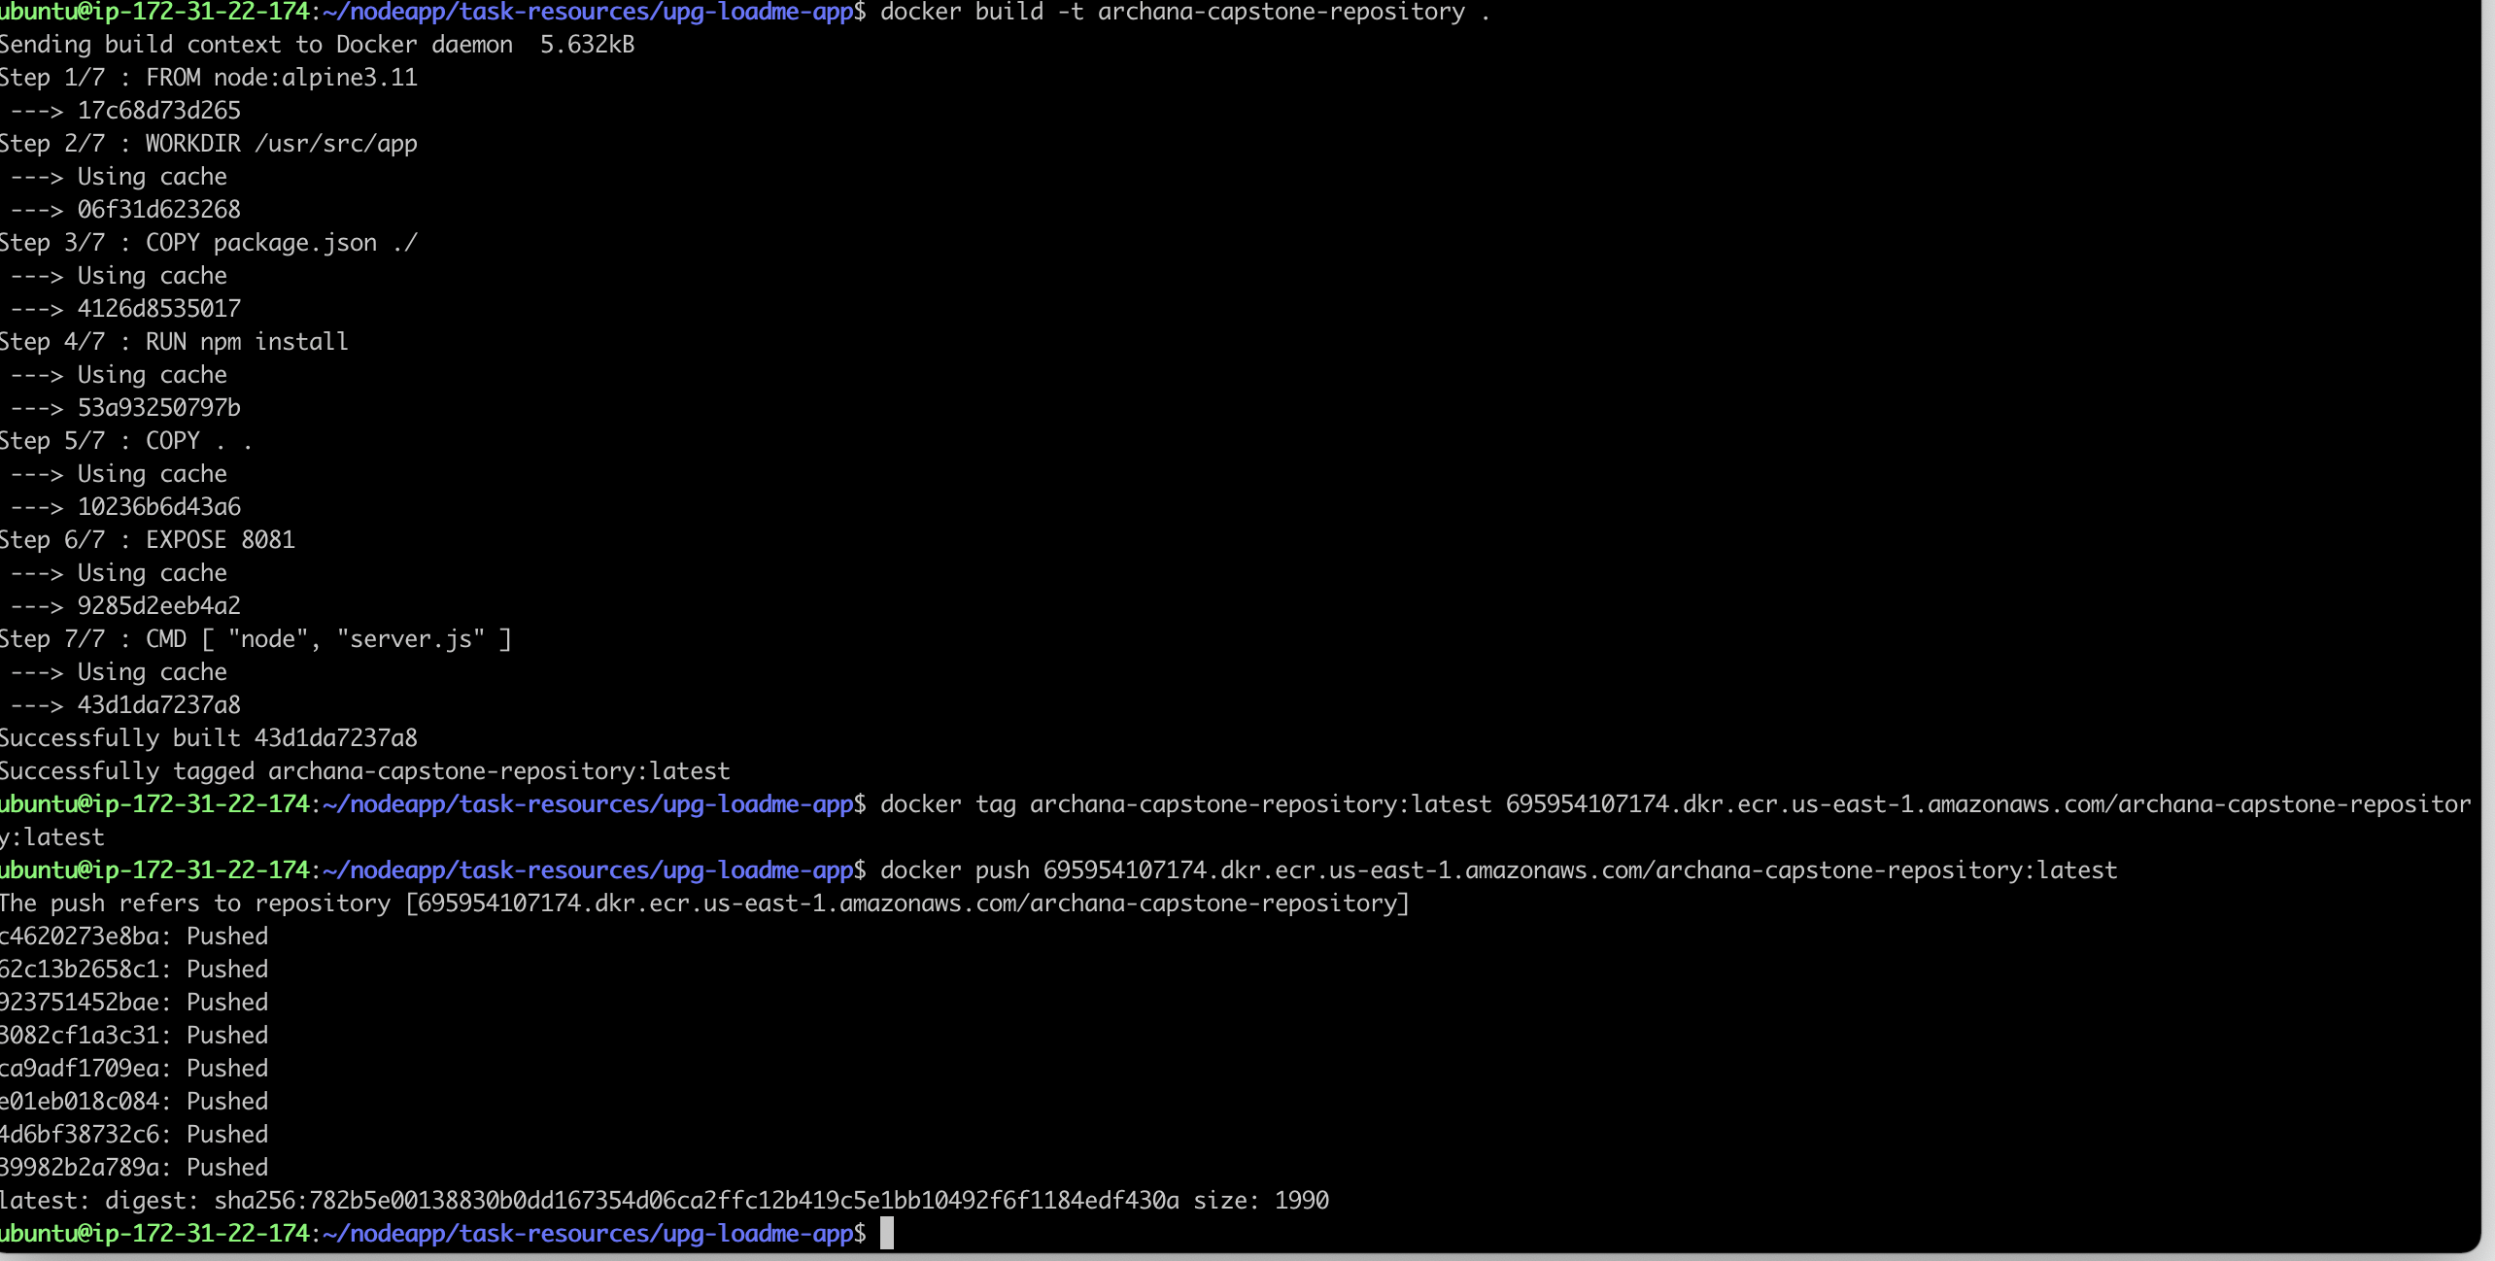

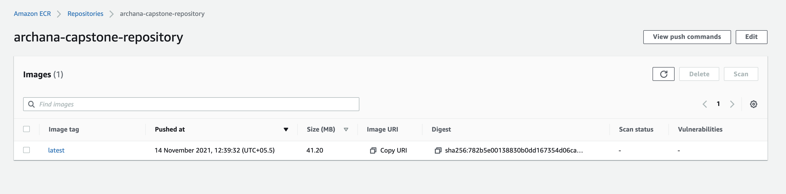

**Task2-Subtask2 – Node group creation with taint**

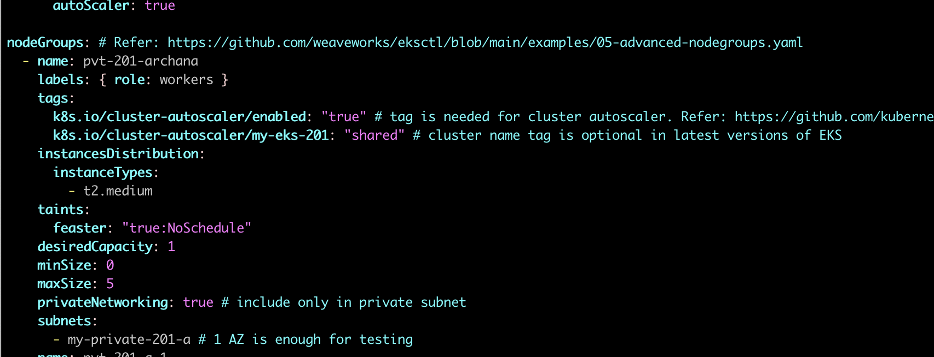

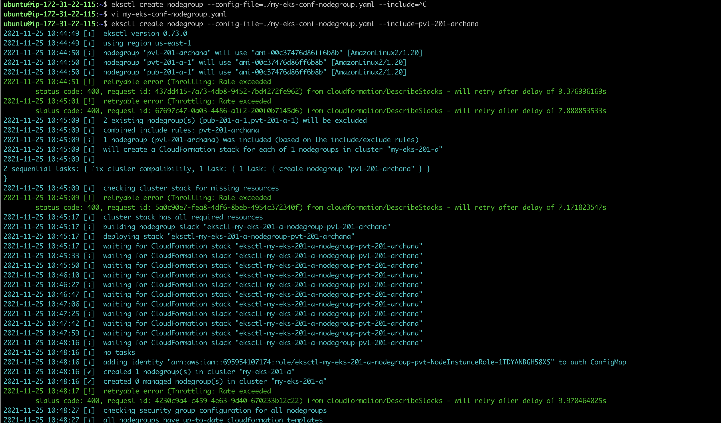

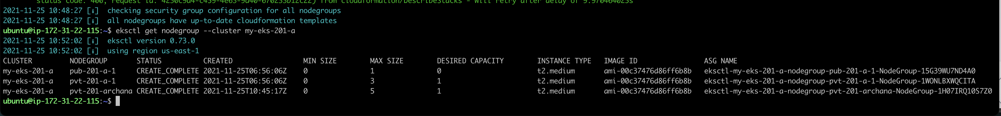

**Task2-Subtask3 – create demo namespace**

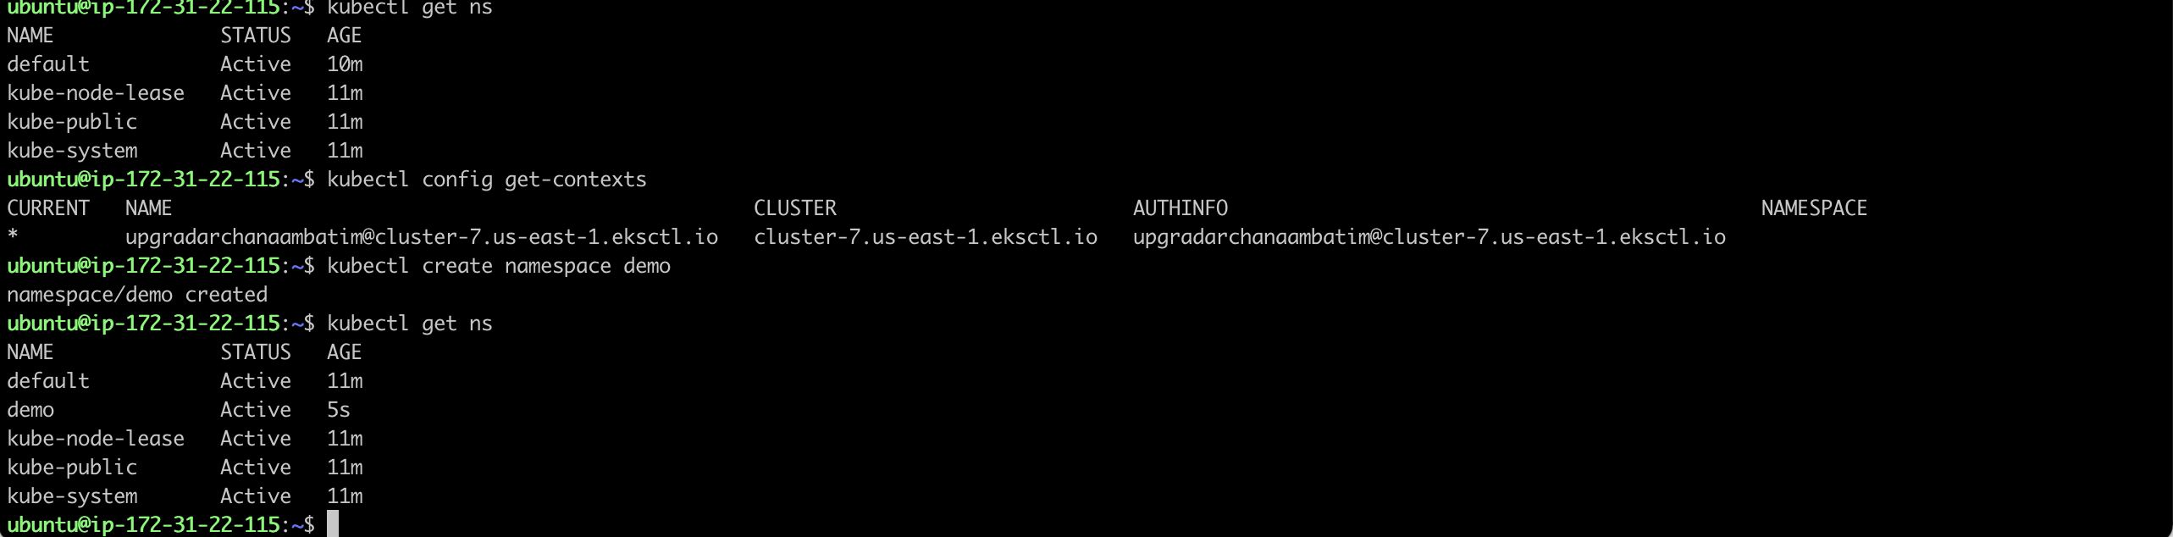

**Task2-Subtask3 – Kubernetes deployment,service and ingress**

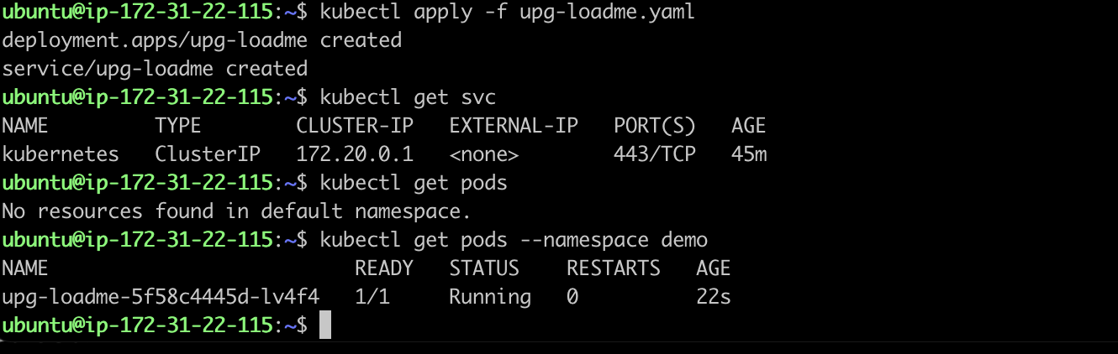



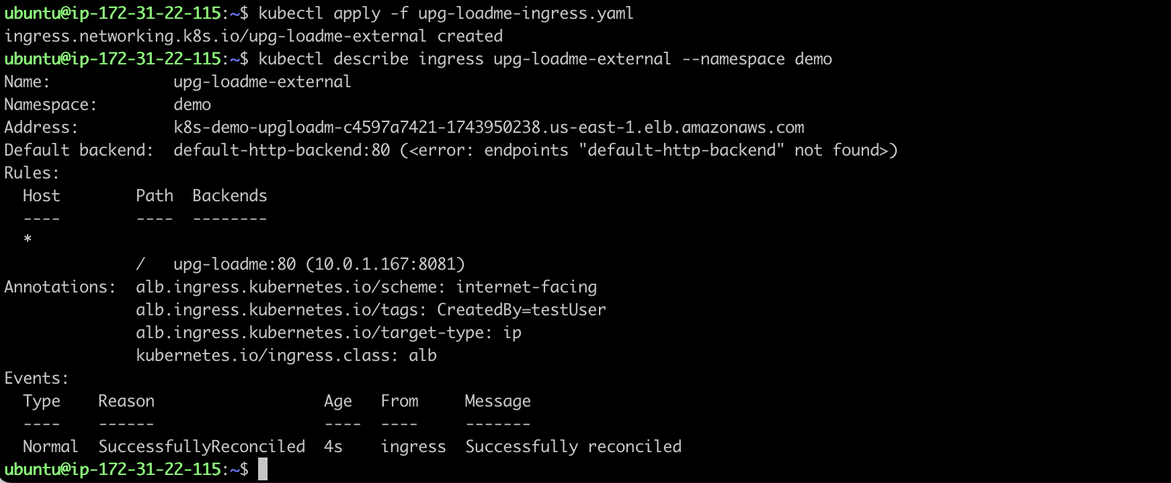

**Node.js running inside pod**

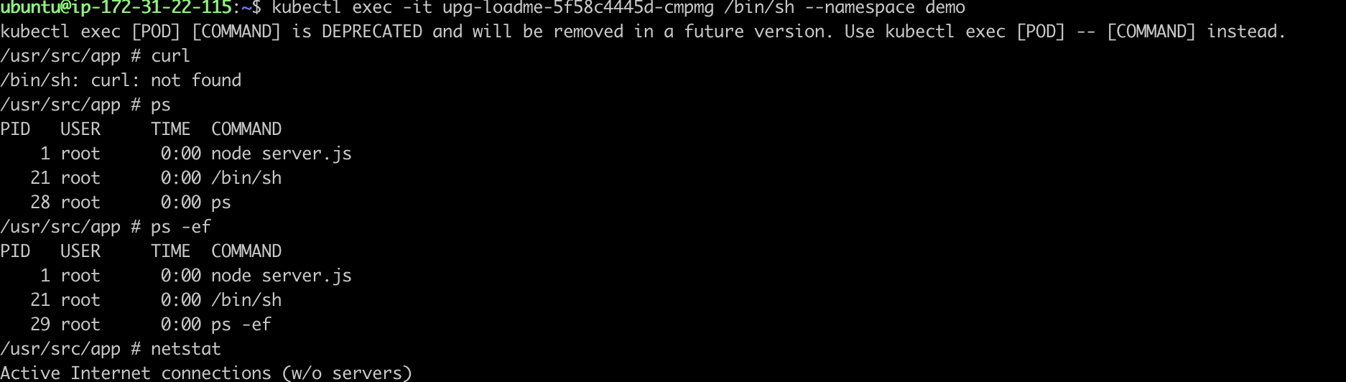

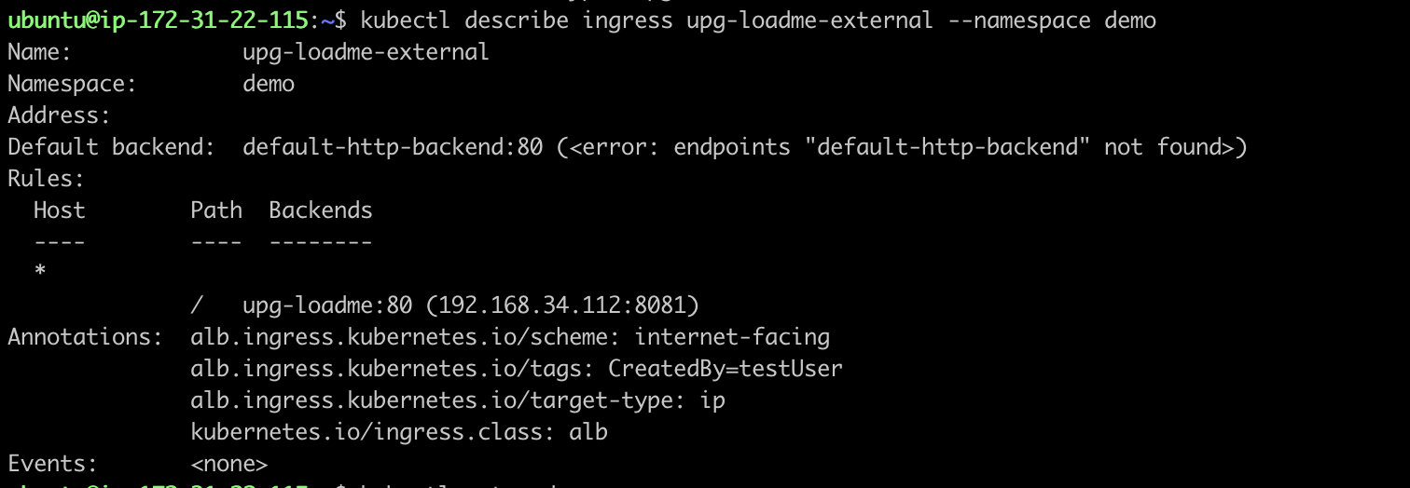

**Iam-oidc-provider**

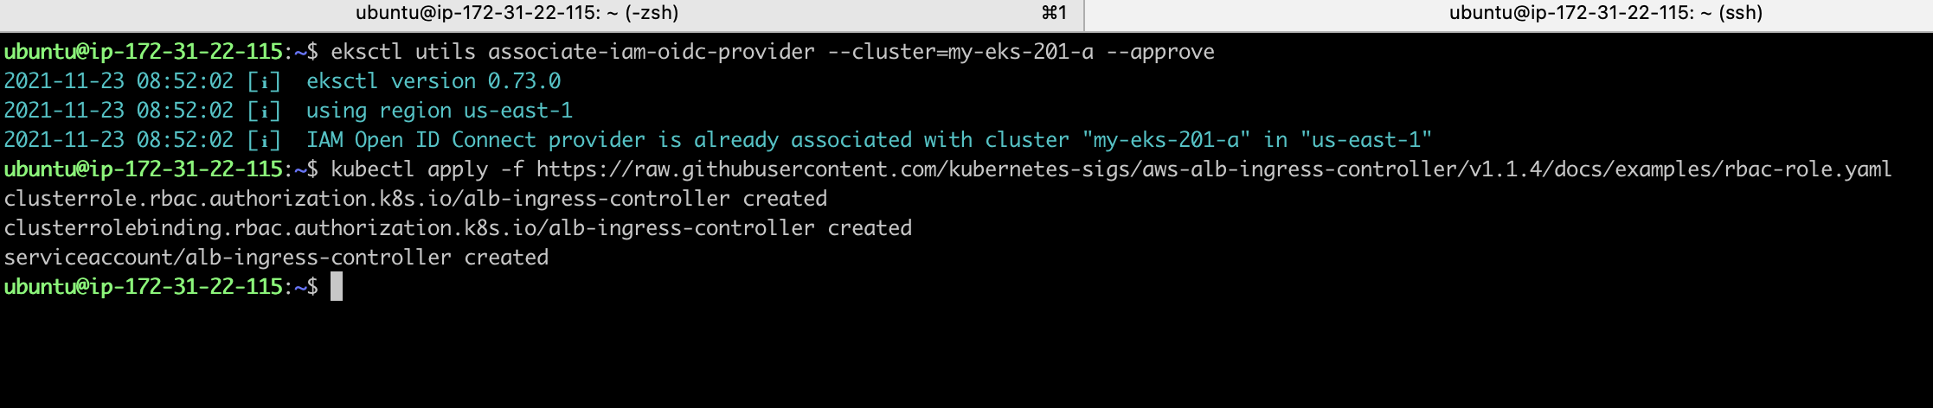

**ALB Created**

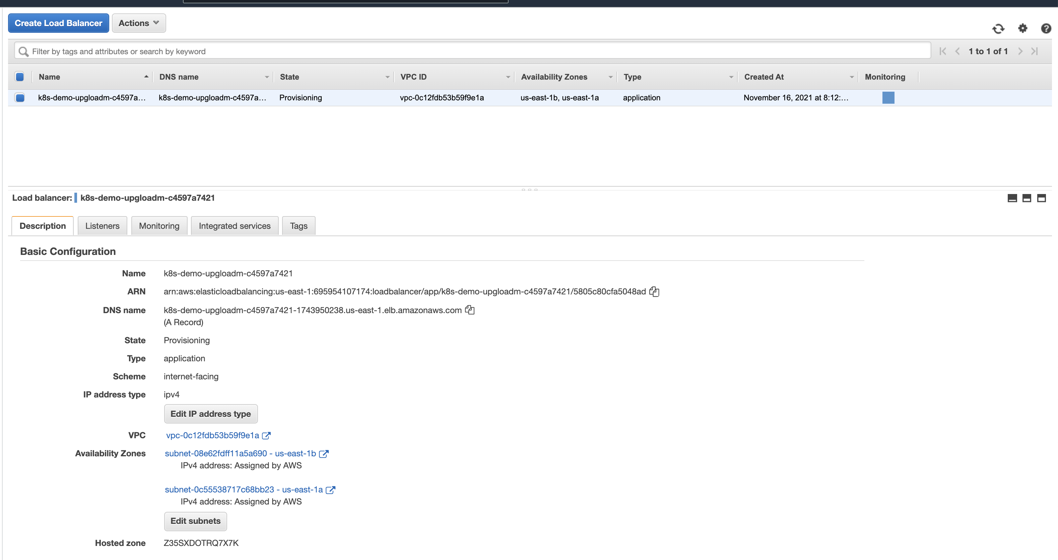

**Task2- Subtask3 : Accessing & Test ‘/’ endpoint from ALB**

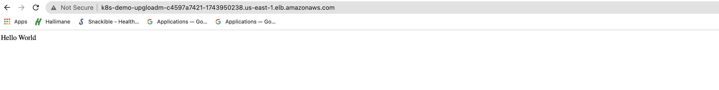

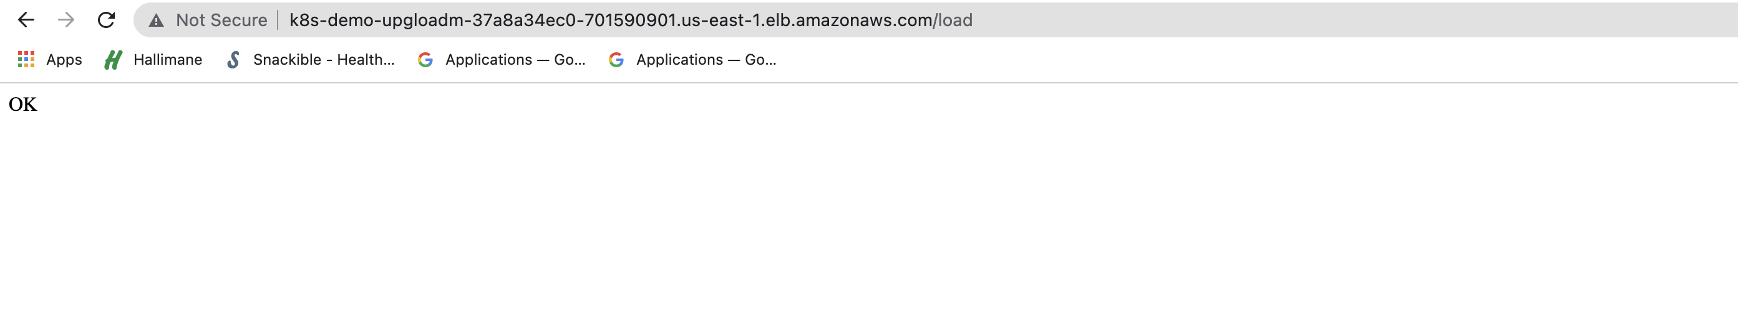

**Task3 – Deploy Redis server on kubernetes**

**Task3- Subtask1: Creating EBS Volume**

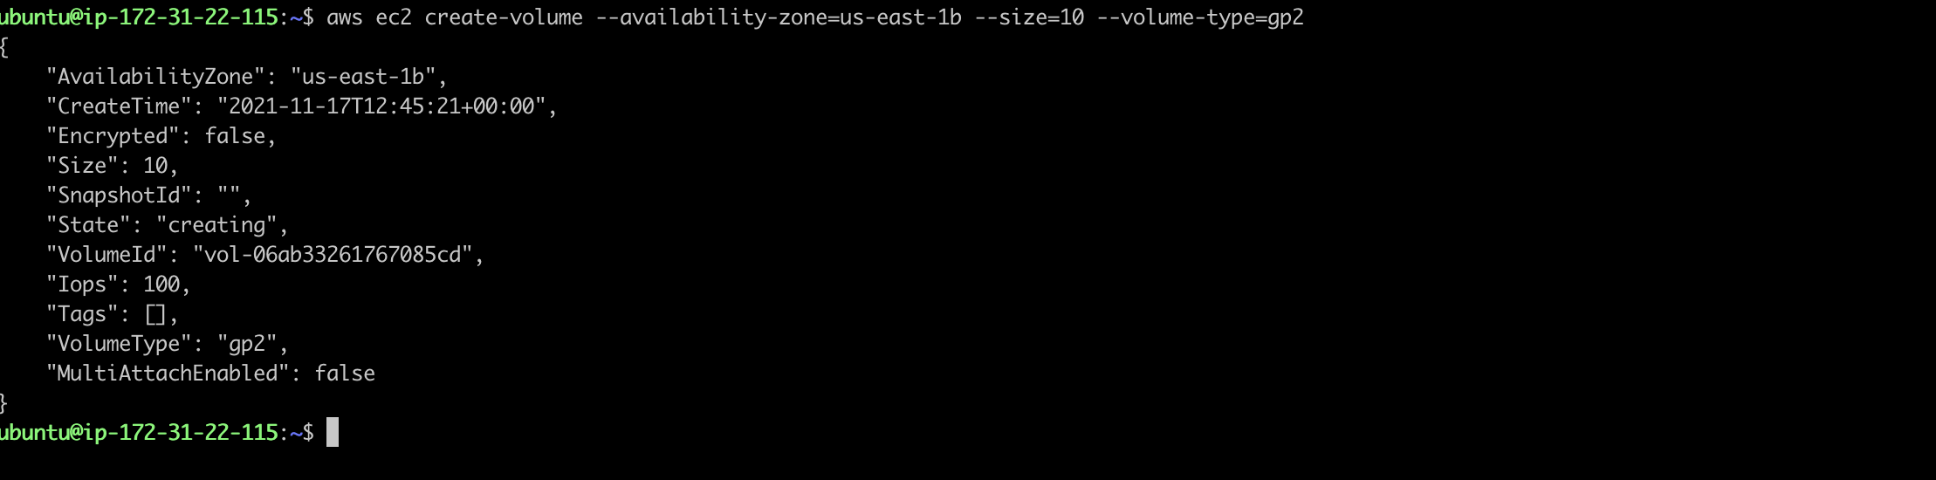



**Task3- Subtask1 : Creating K8s PV & PVC**

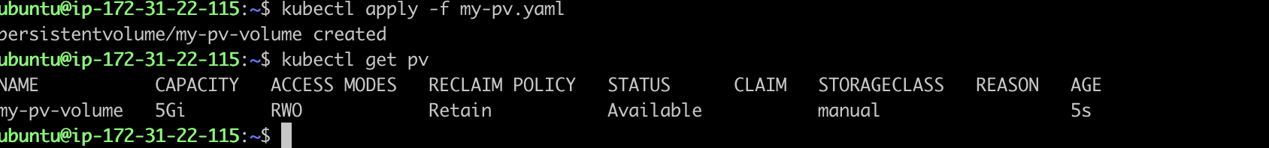

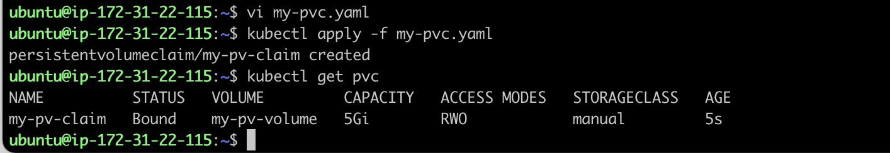

**Task3 – Subtask1 : Redis pod using PVC**

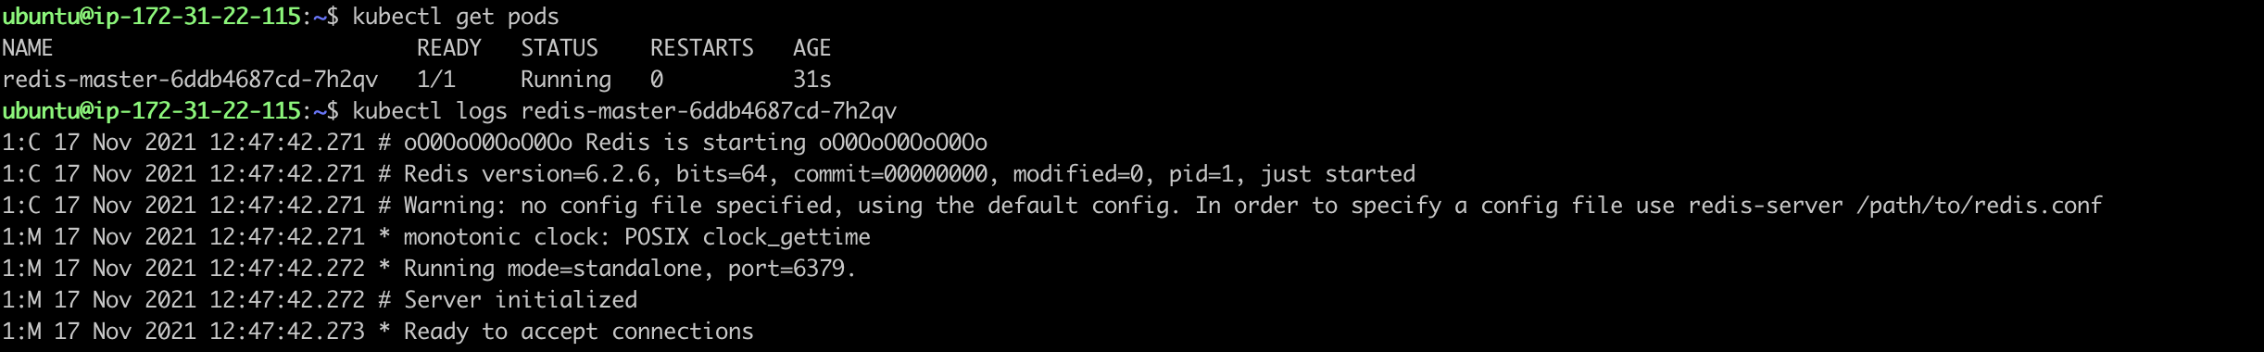

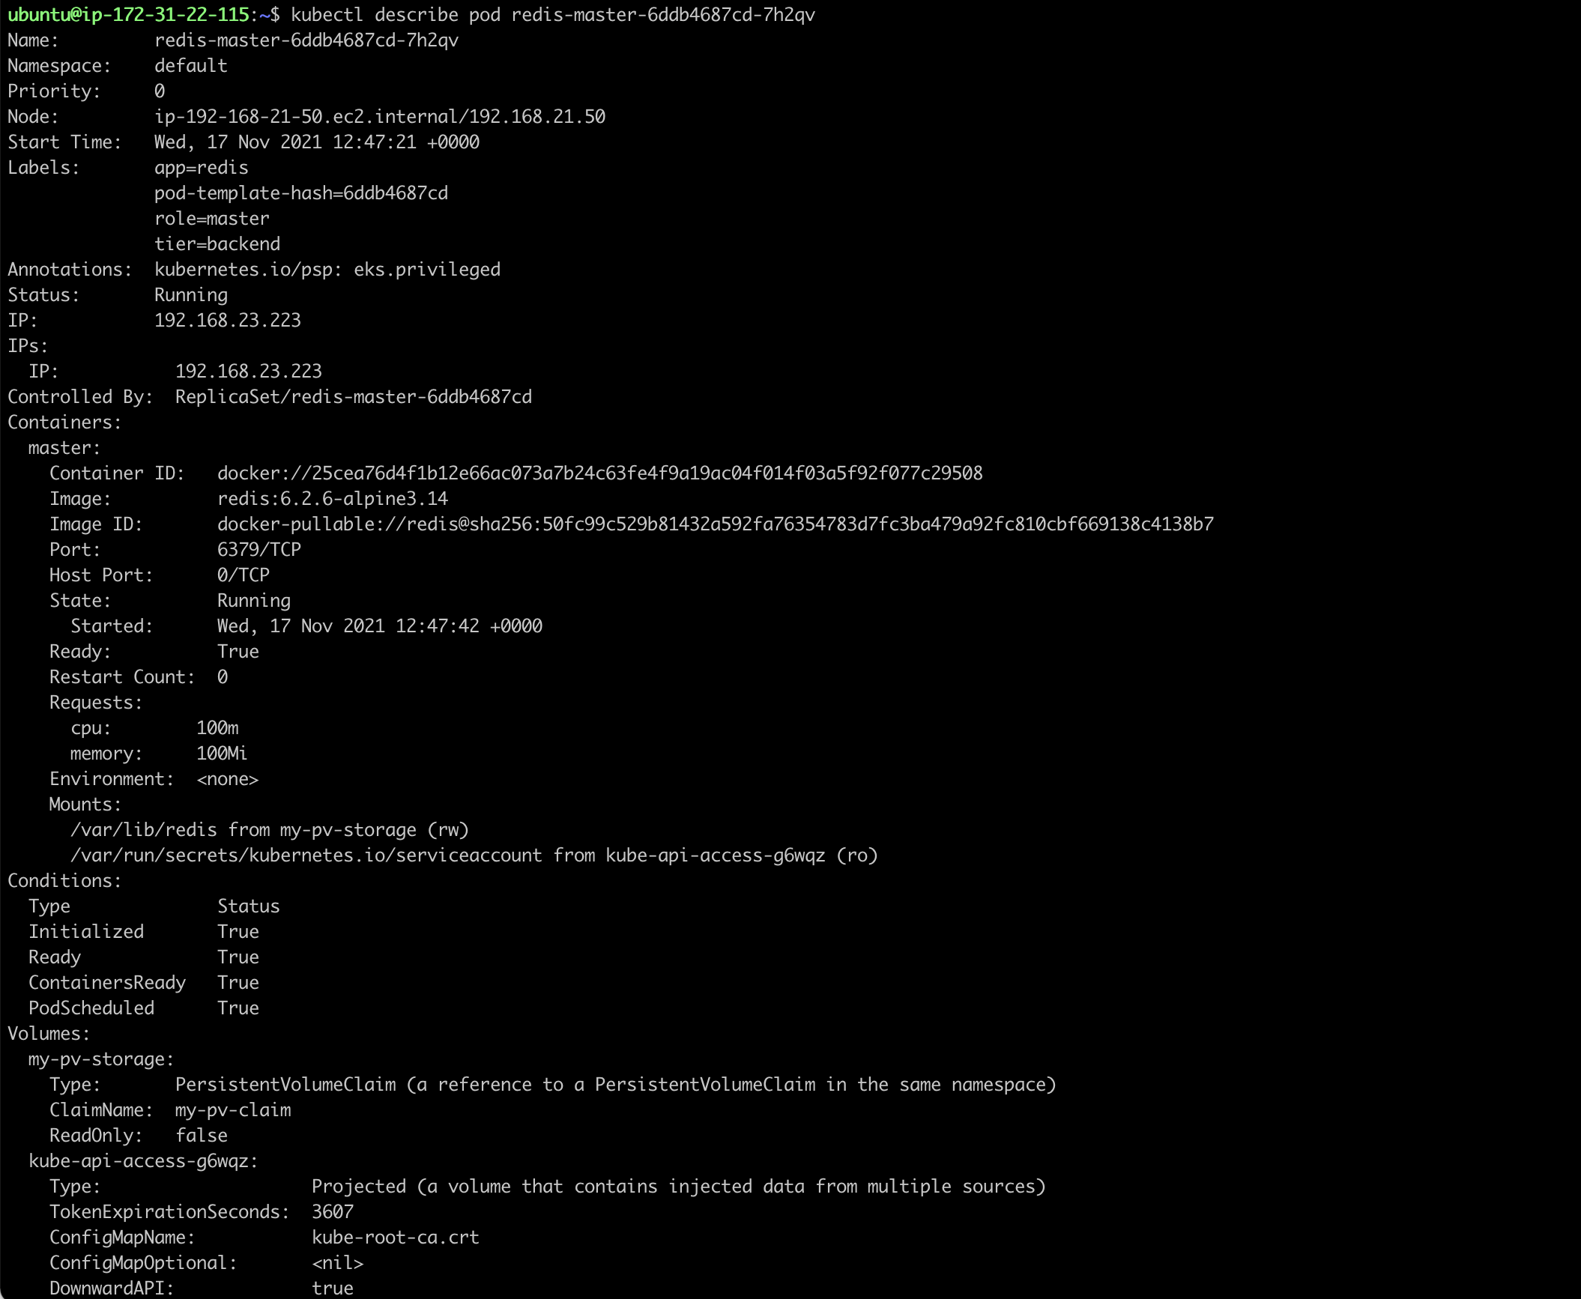

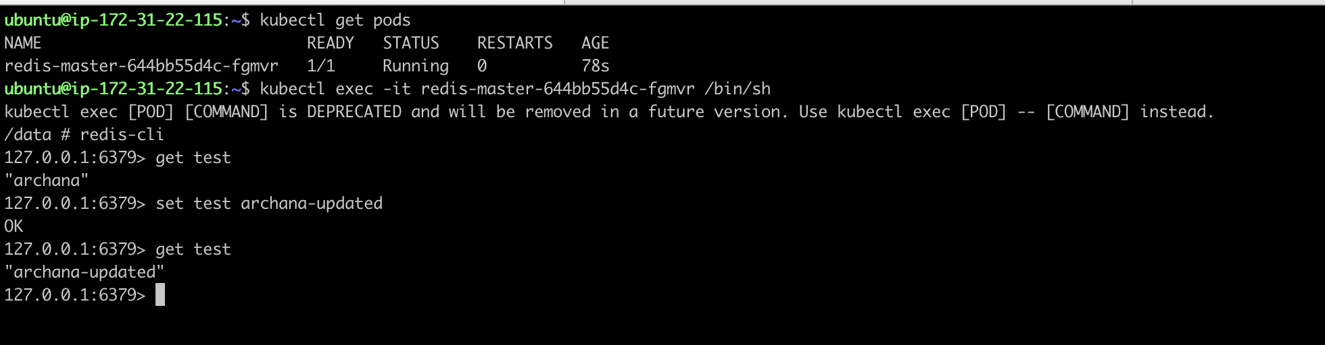

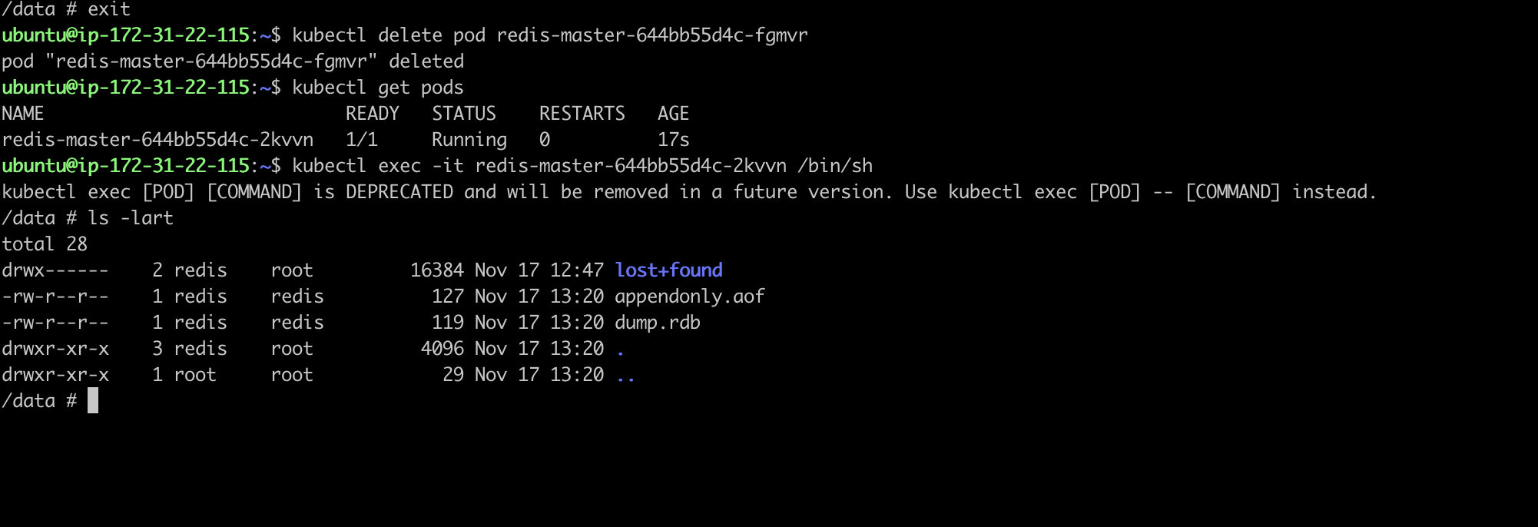

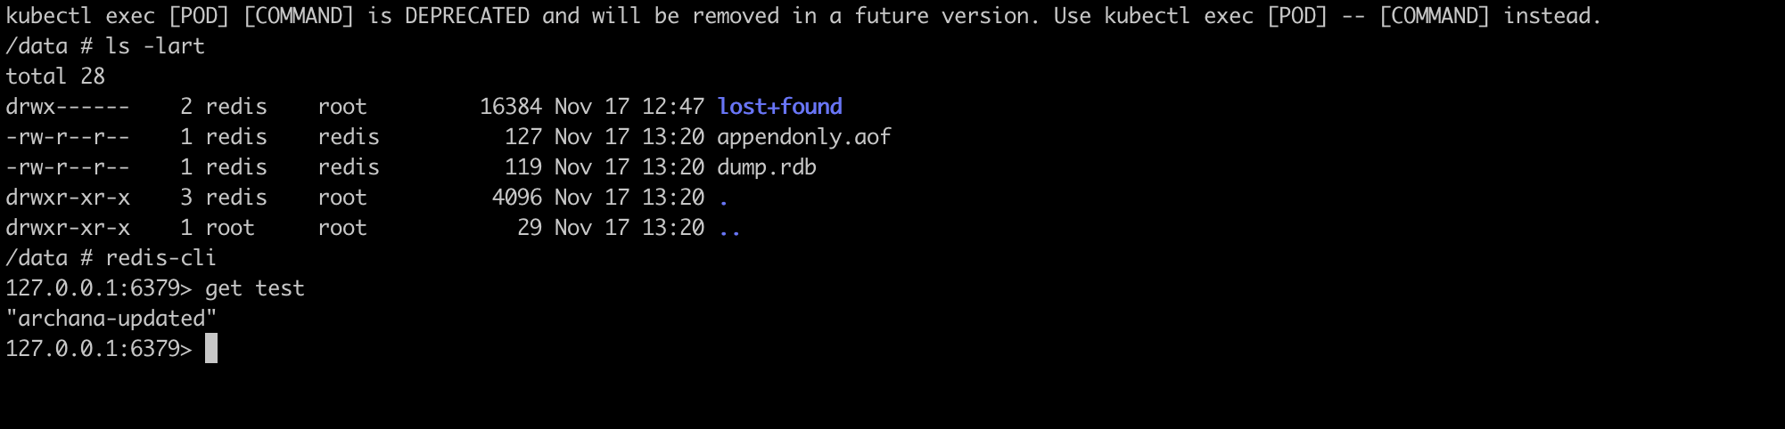

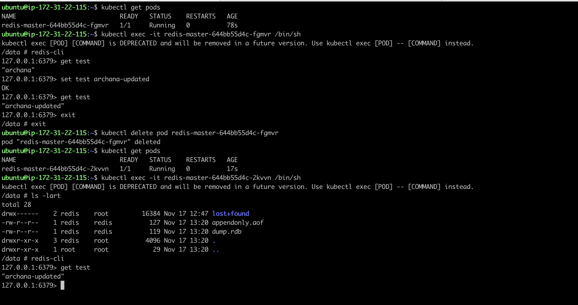

**Task3-Subtask1 : config map**

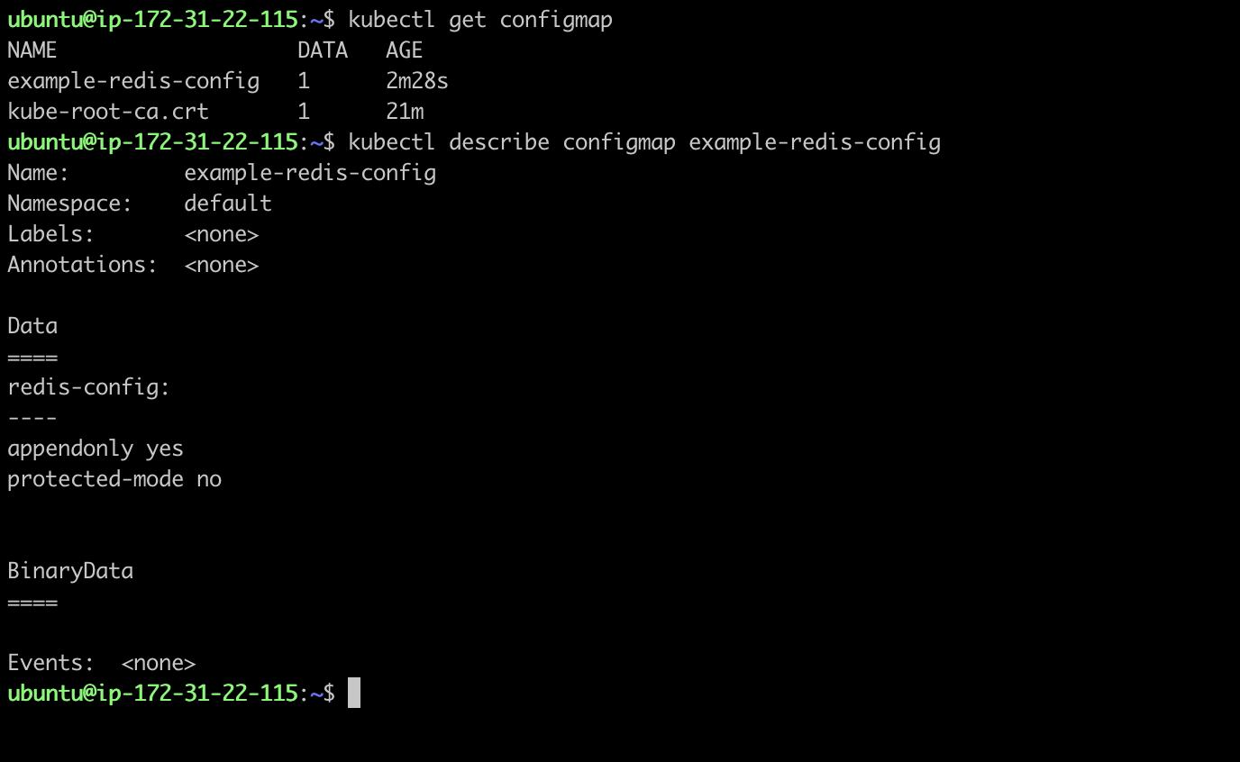

**Task3 – Subtask2 : redis-cli deployment**

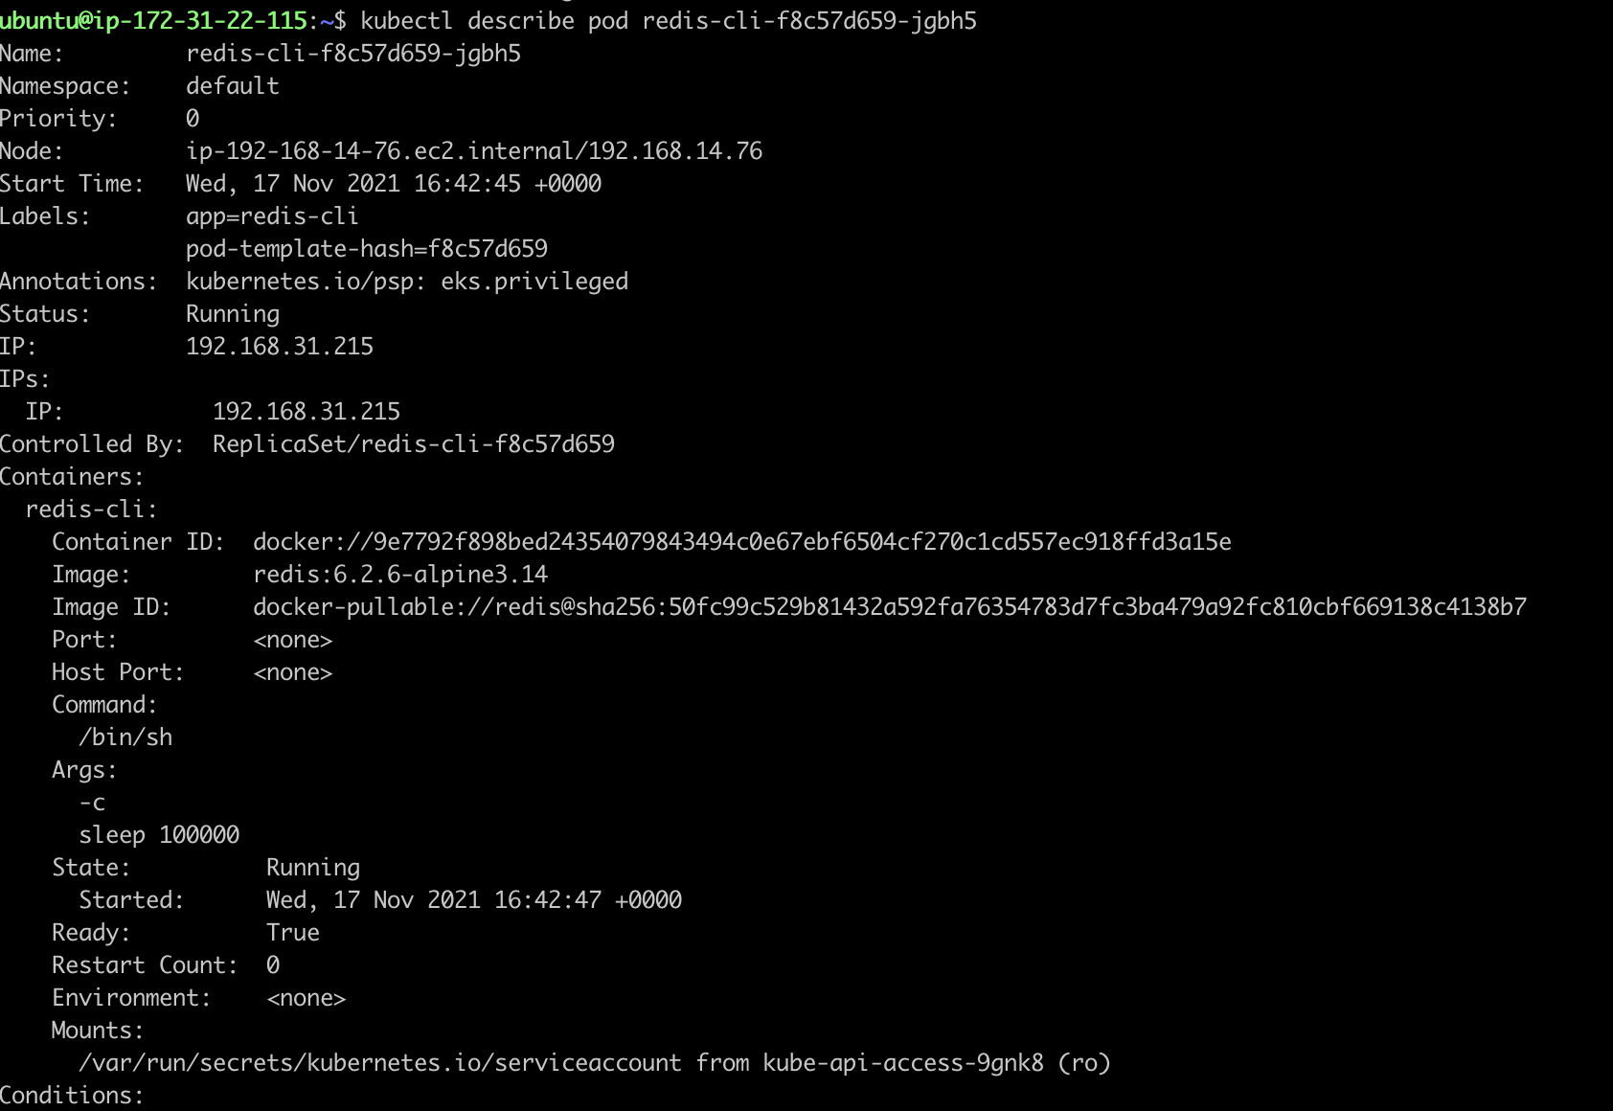

**Task3 – Subtask3 : connect to service from redis-cli & store some key value pairs**

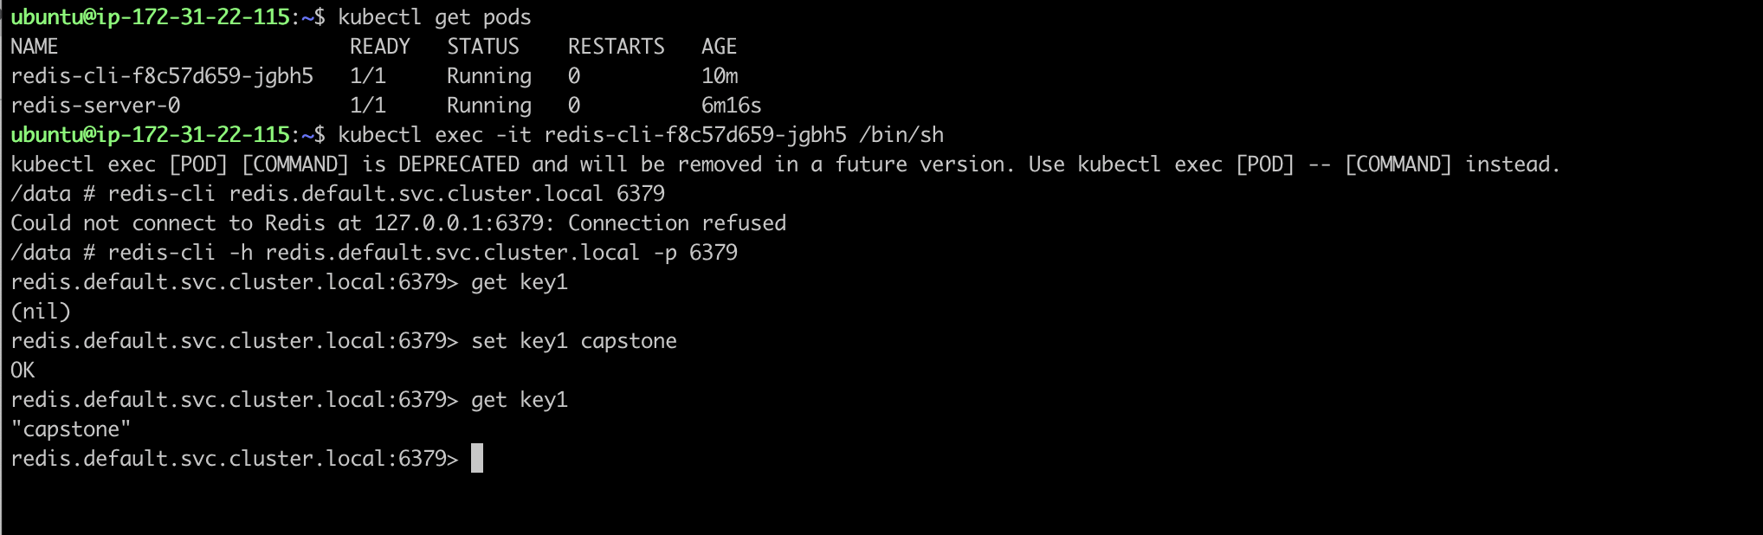

**Task3 – subtask3 : Delete the pod & wait for restart**

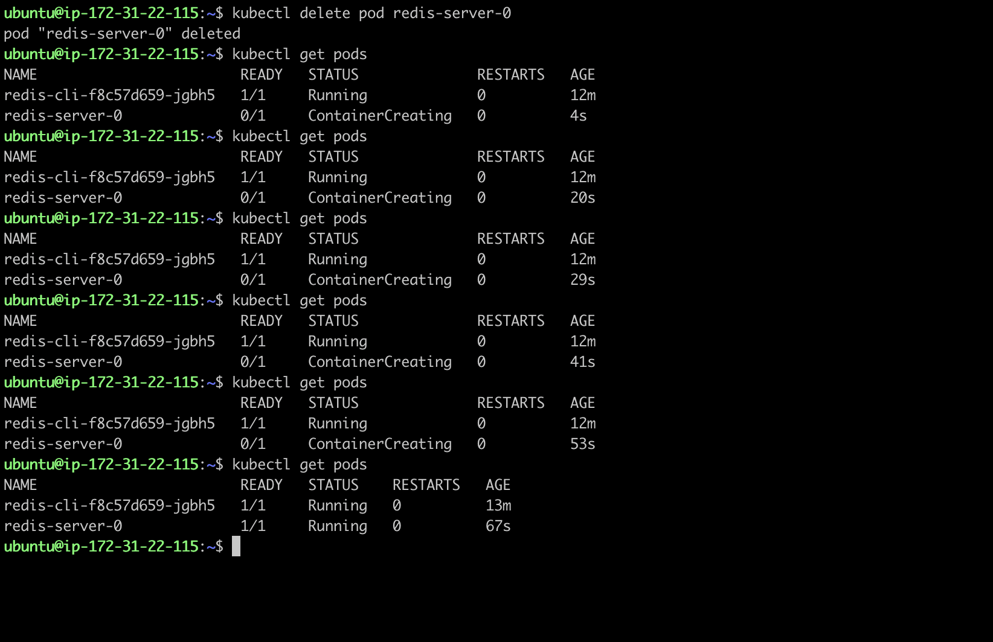

**Task3-subtask3 : verify key-value pairs from new pod**

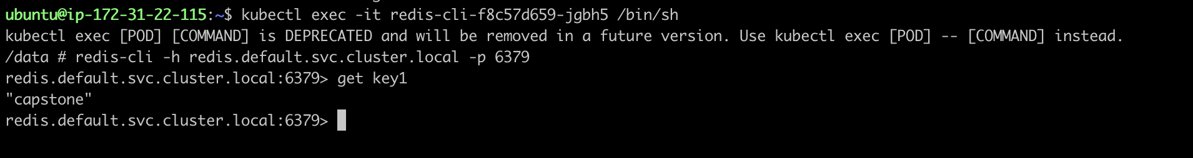

**Task-4: Test auto scaling of the application**

**Task-4 – Subtask-1 : HPA**

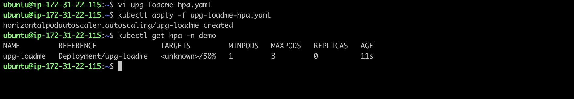

**Task-4- Subtask-2 : Prometheus installation**

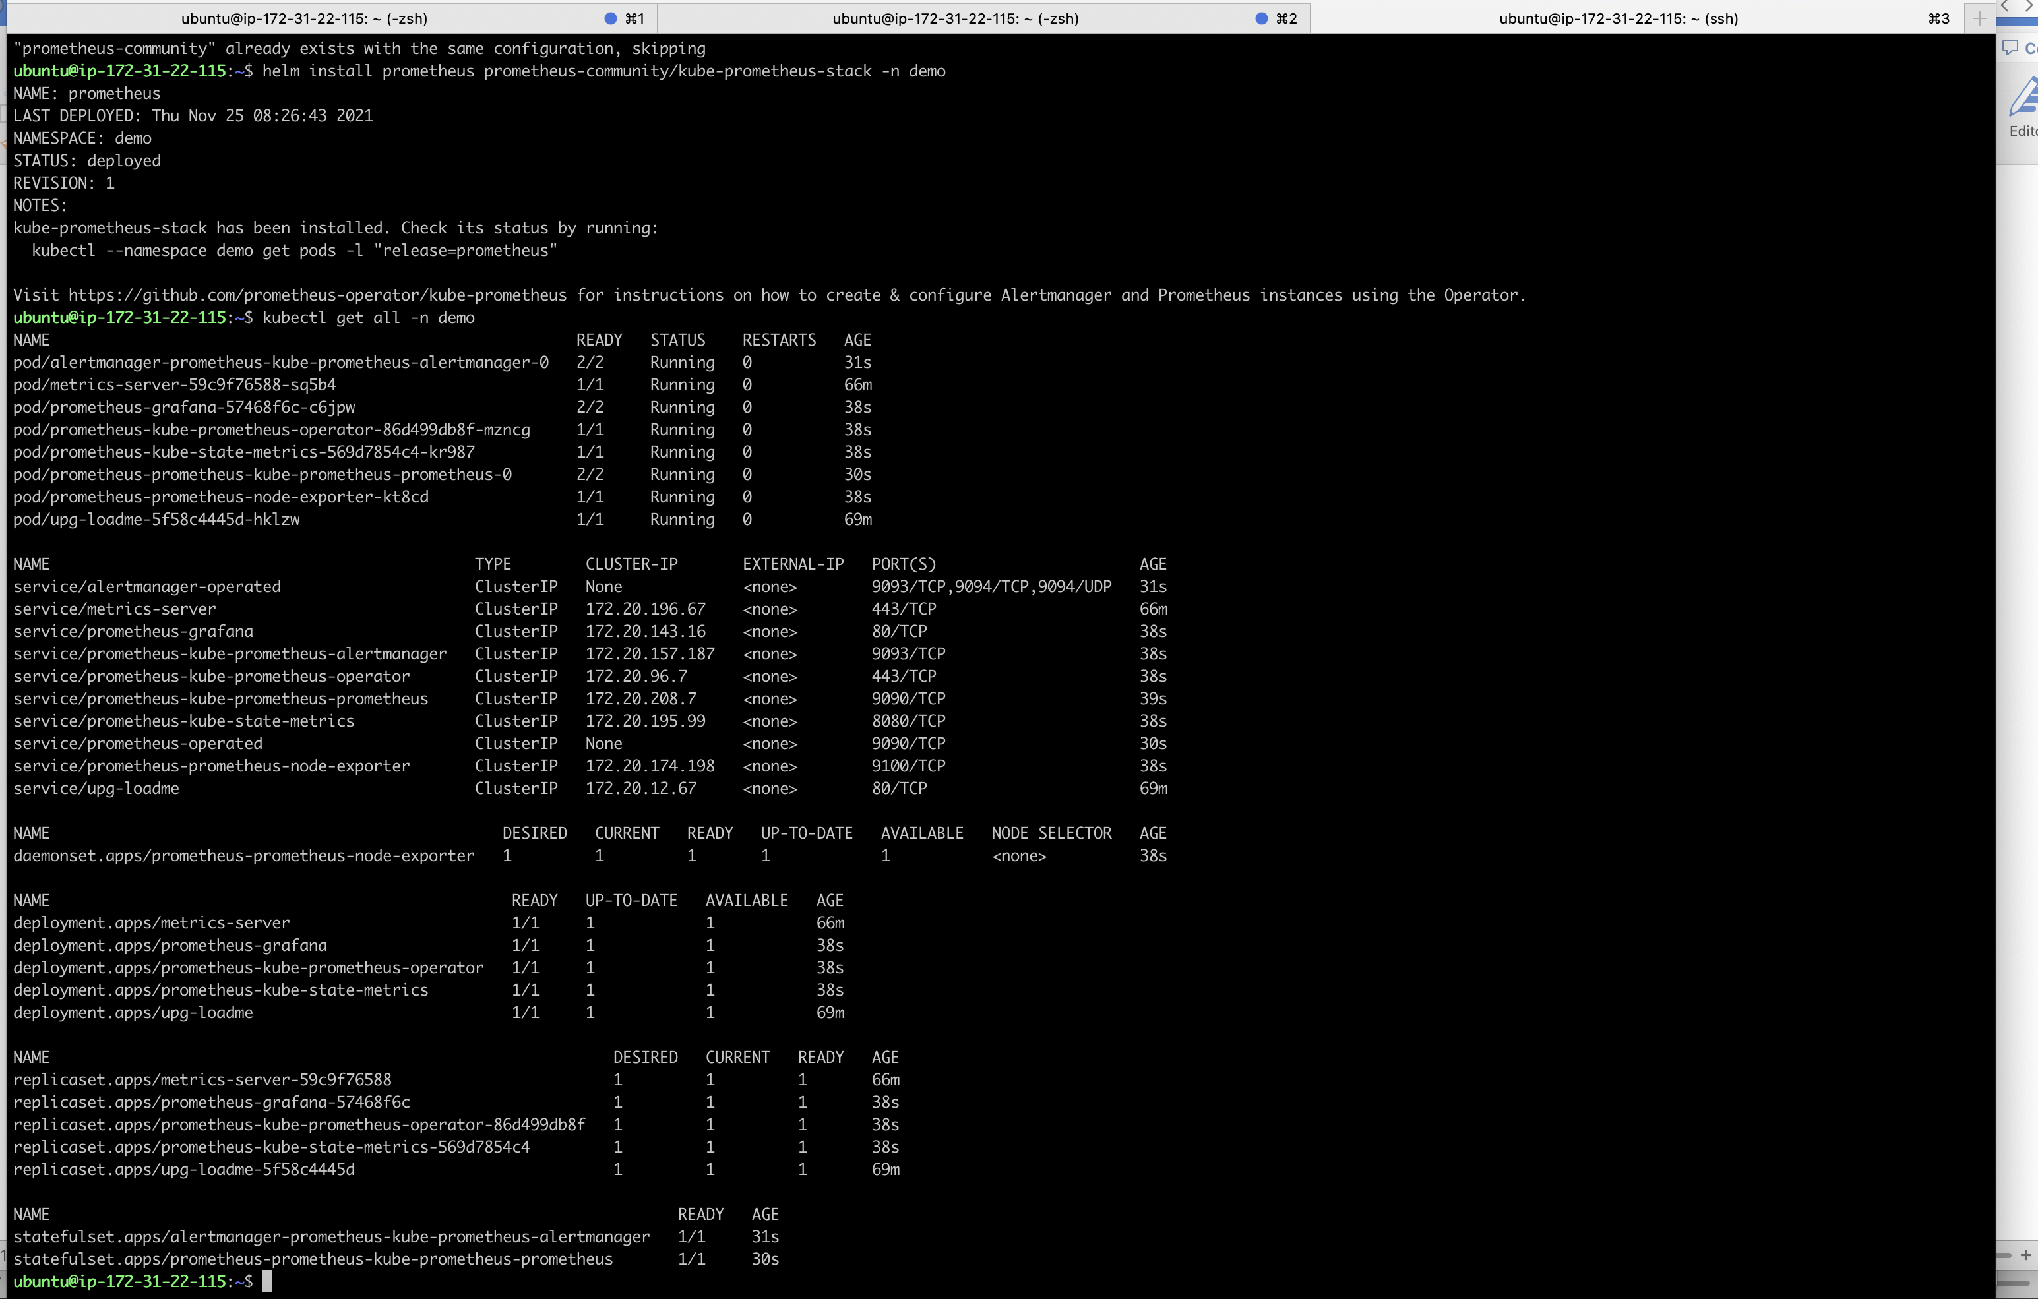

**Task-4-subtask-2 : Port forward for Prometheus & Grafana**

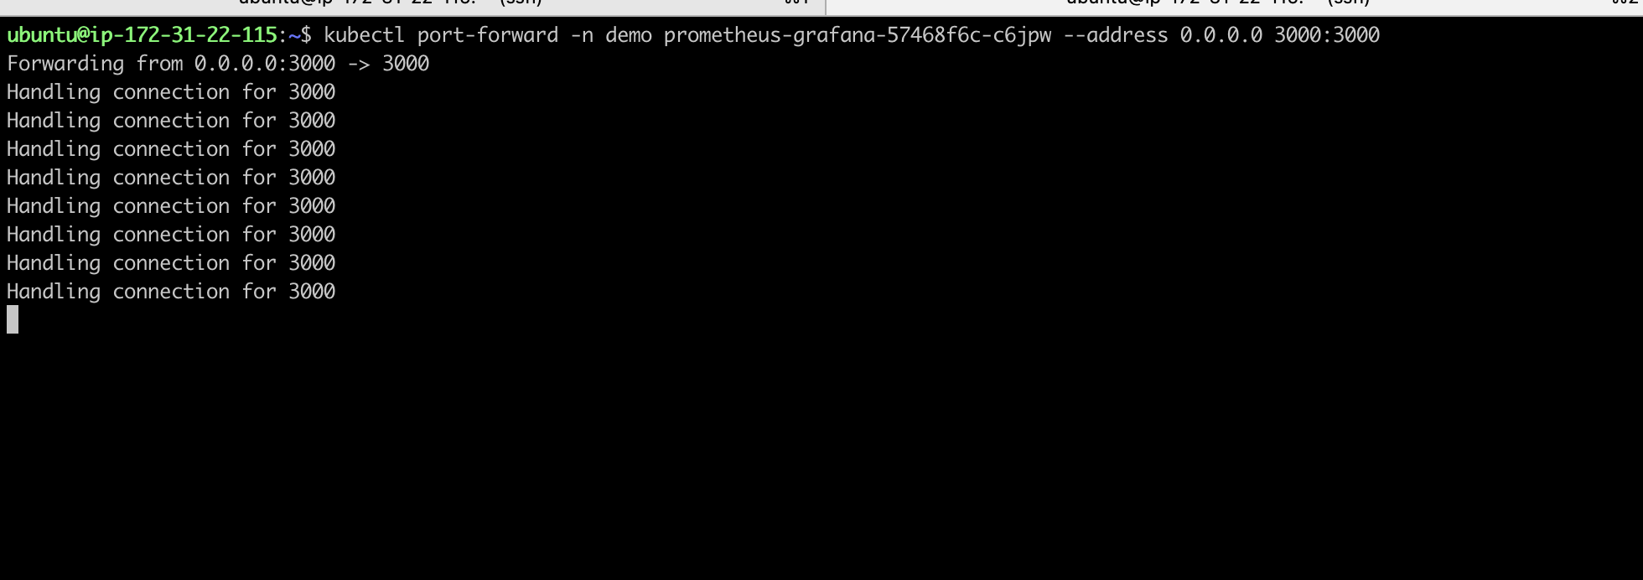

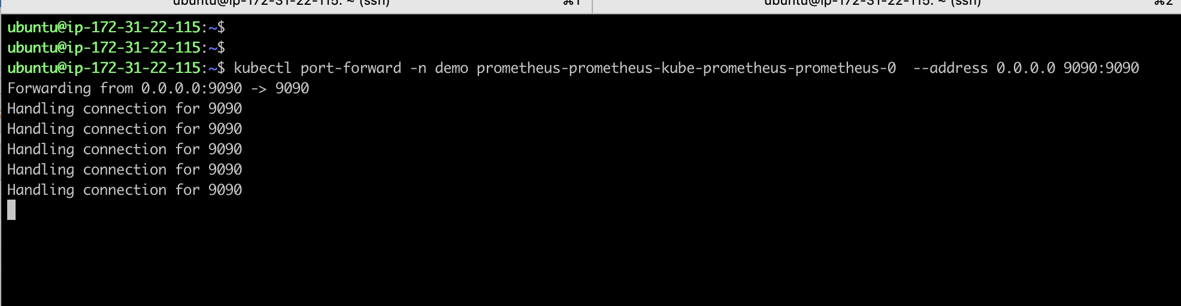

**Grafana Dashboard**

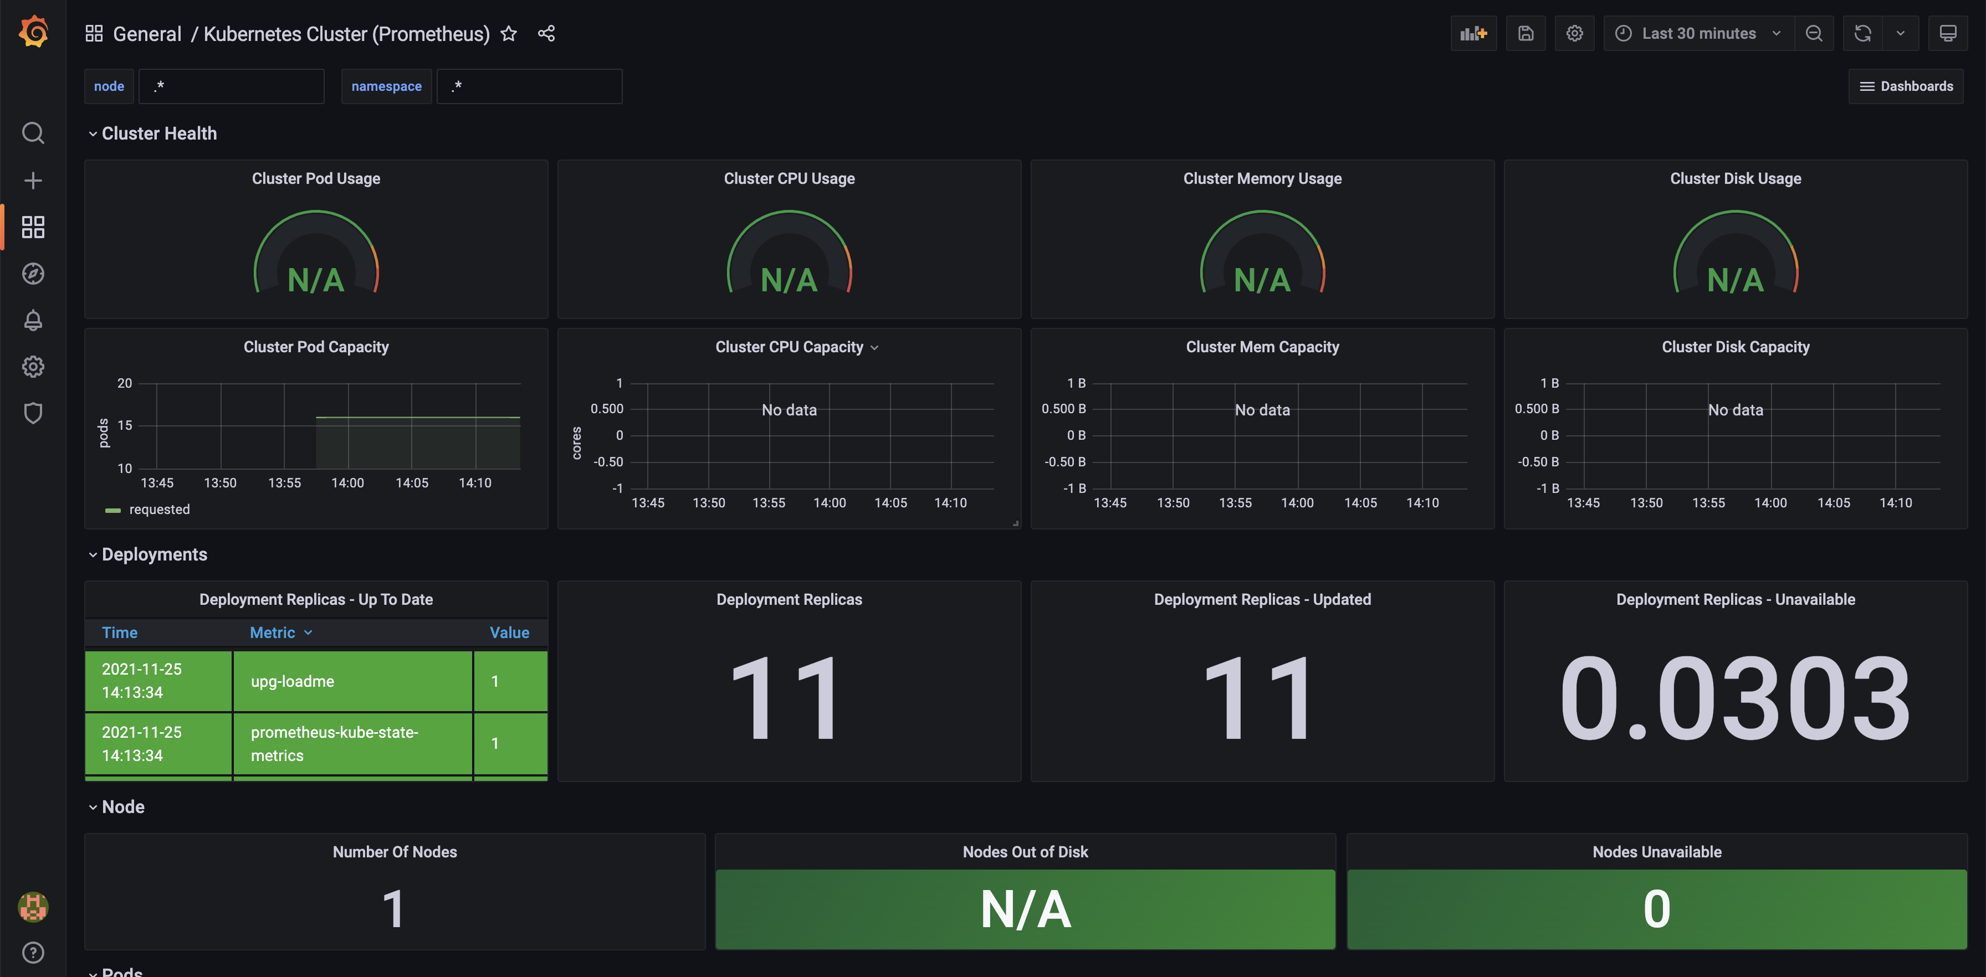

**Prometheus Dashbaord**

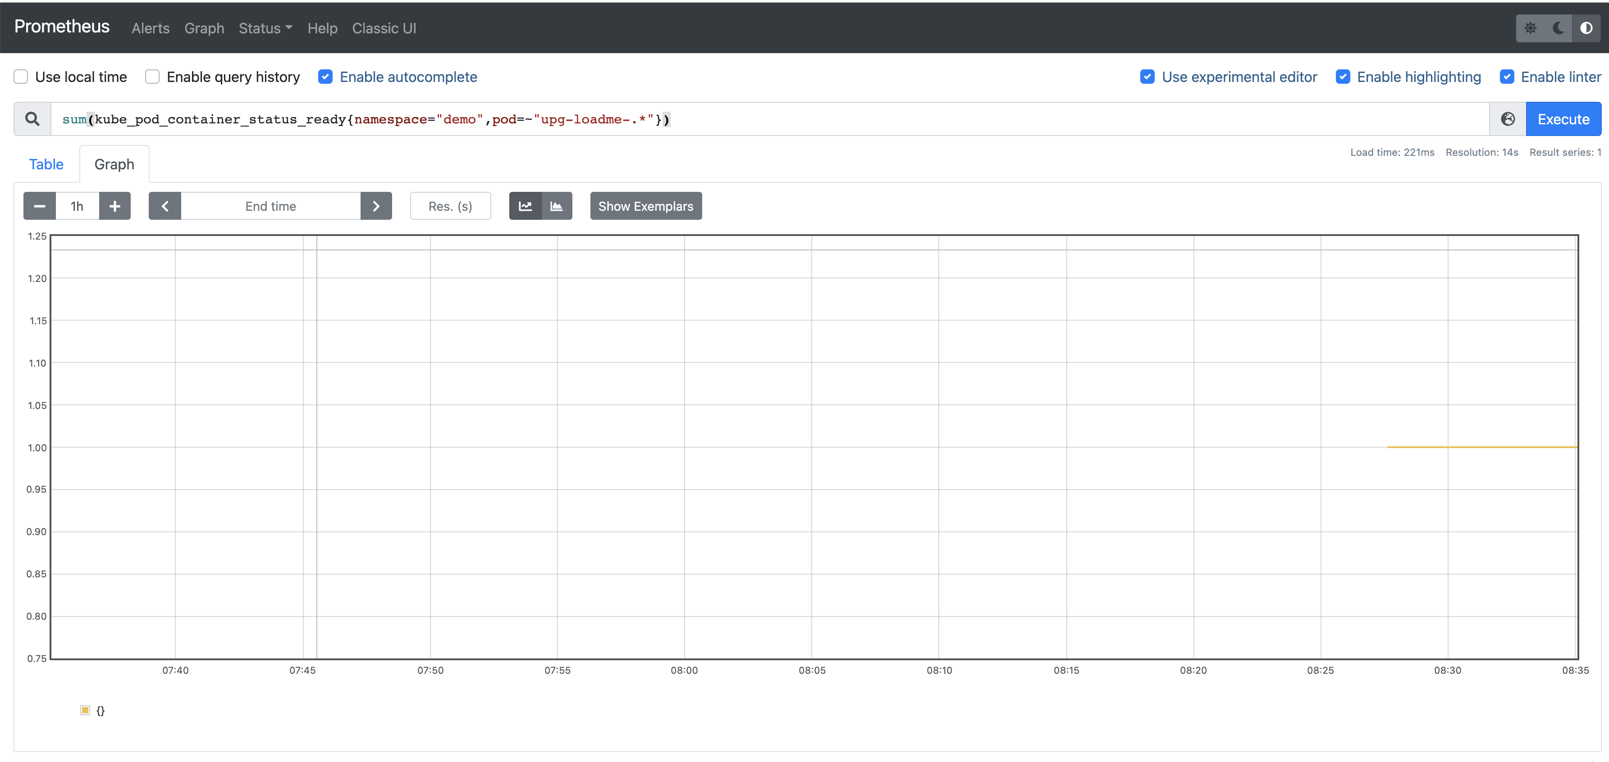

**Task-4-subtask-3 : ab installation**

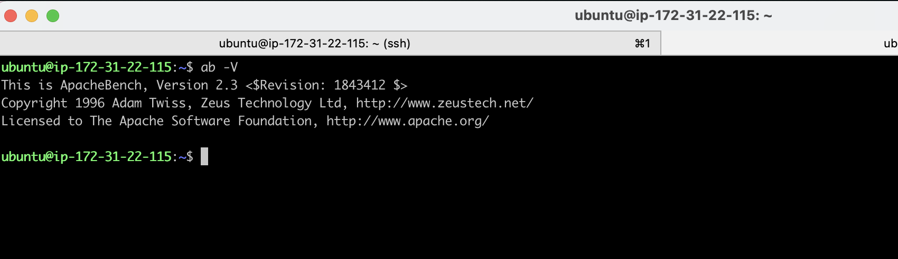

**Kubectl top pods**

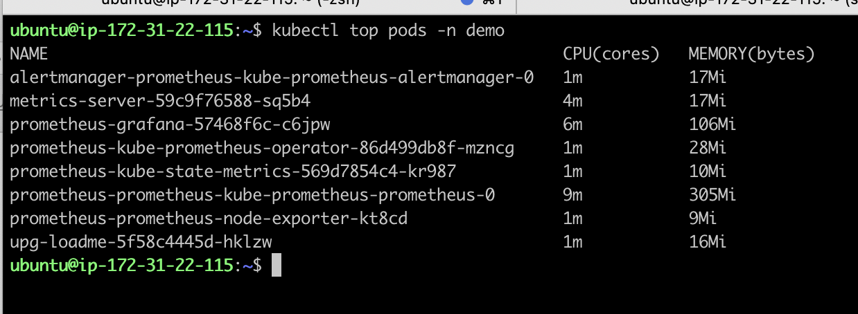

**Load test application**

ab -n100 -c10 'http://k8s-demo-upgloadm-37a8a34ec0-701590901.us-east-1.elb.amazonaws.com/load?scale=100'

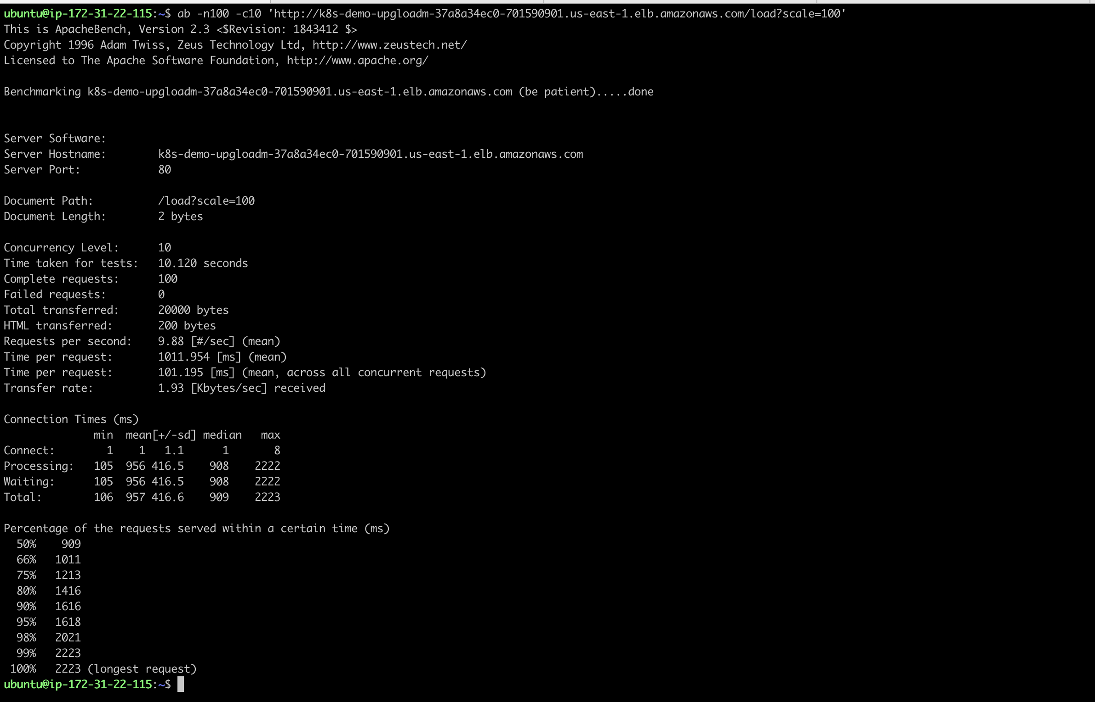

After increasing load

ab -n200 -c10 'http://k8s-demo-upgloadm-37a8a34ec0-701590901.us-east-1.elb.amazonaws.com/load?scale=200'

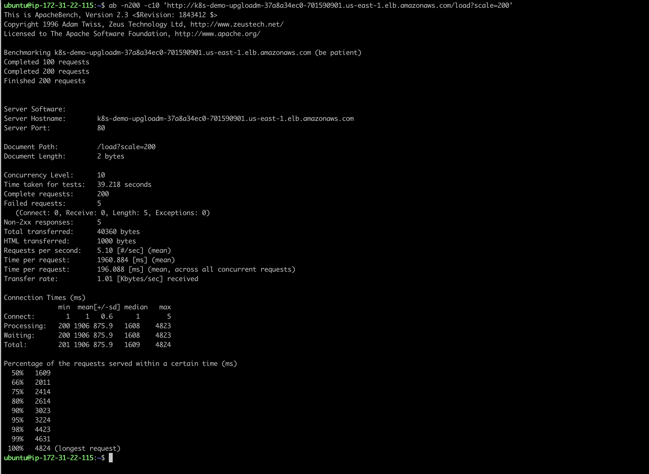

**scaling up with load**

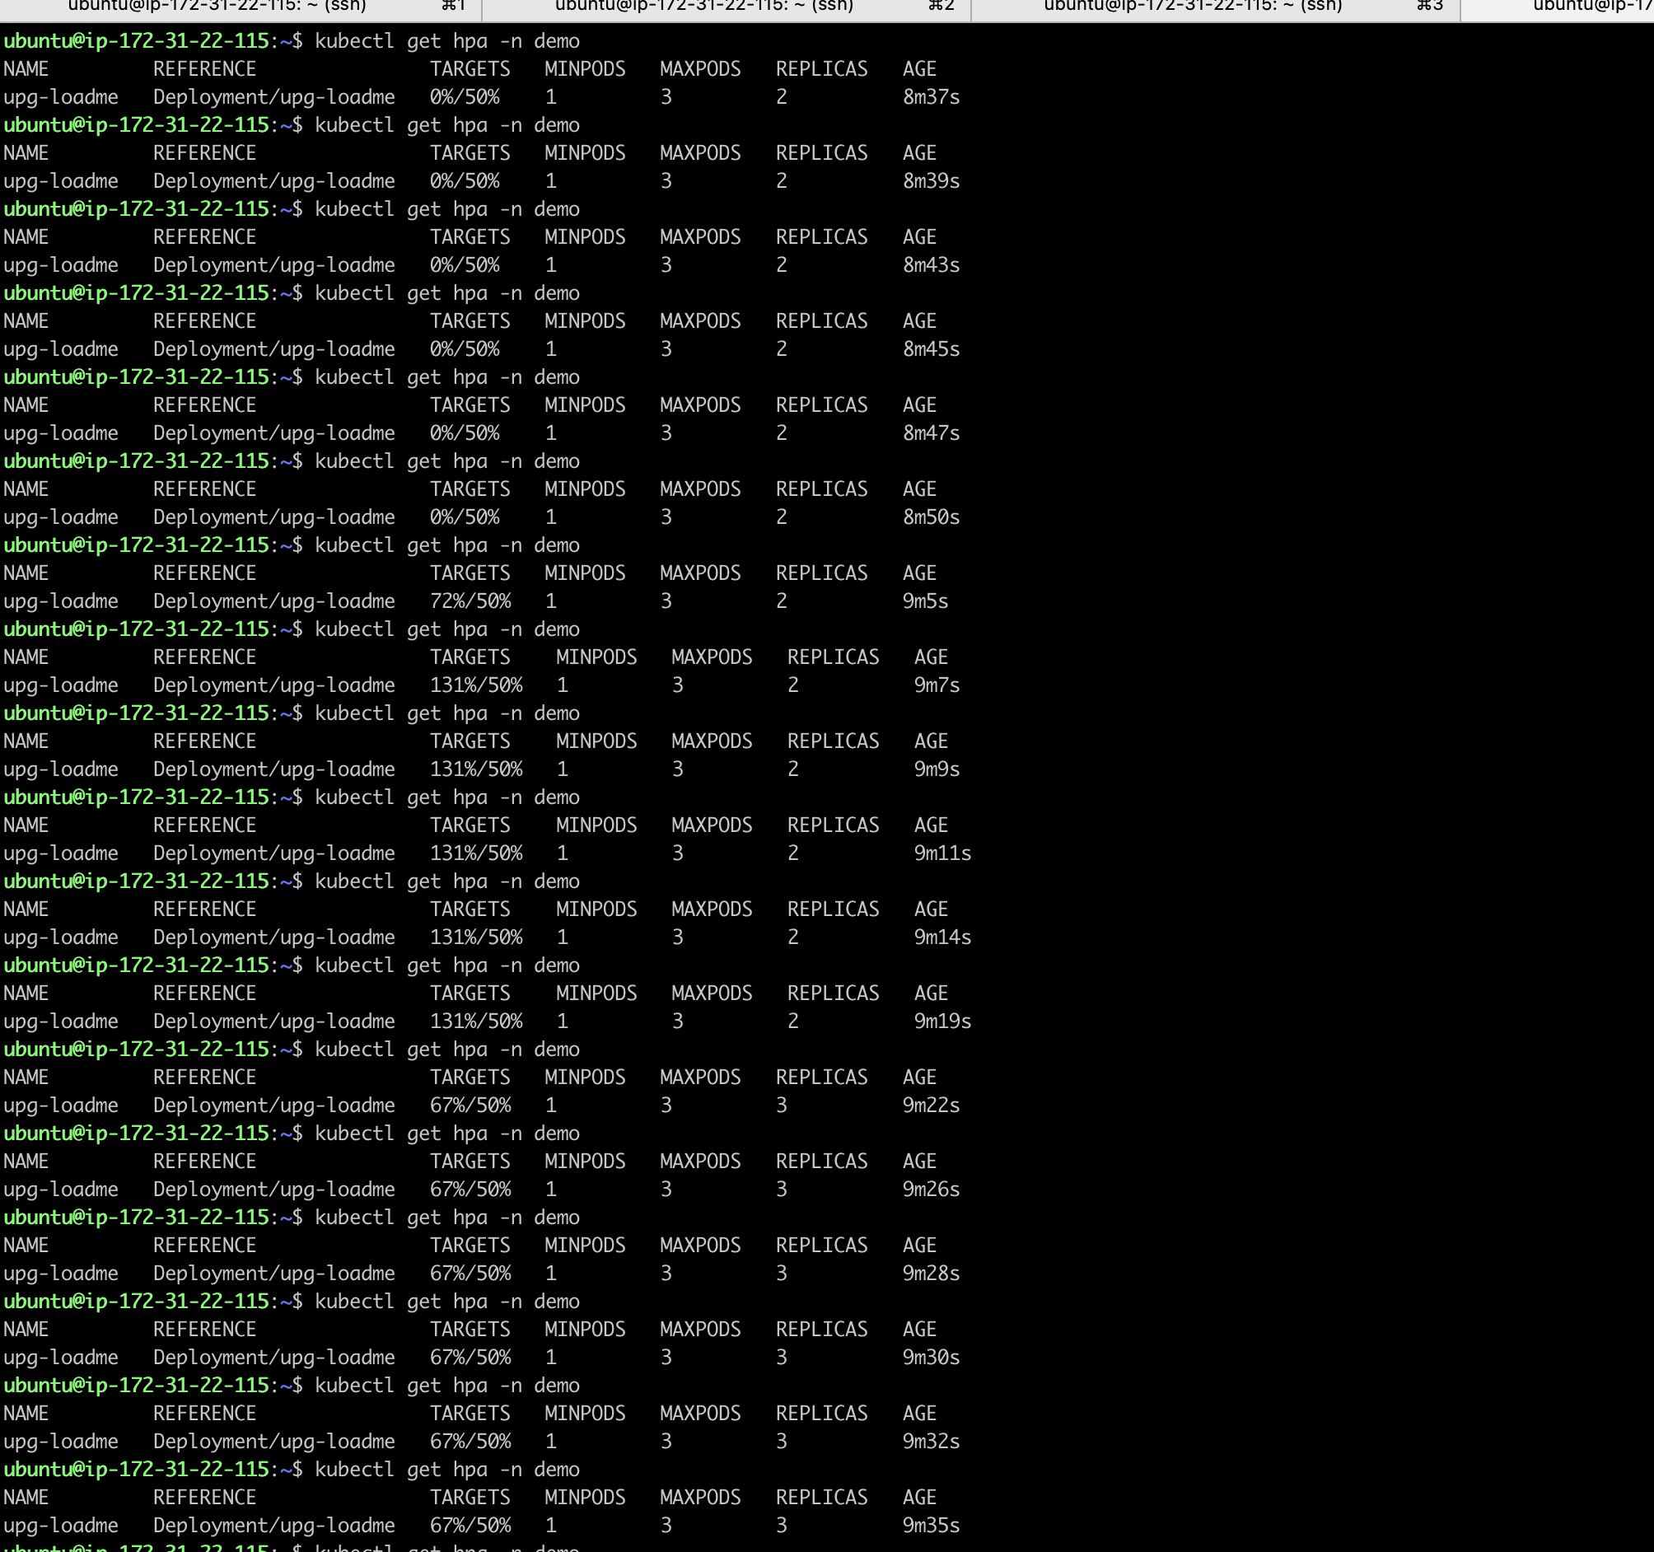

**scaling down with less load**

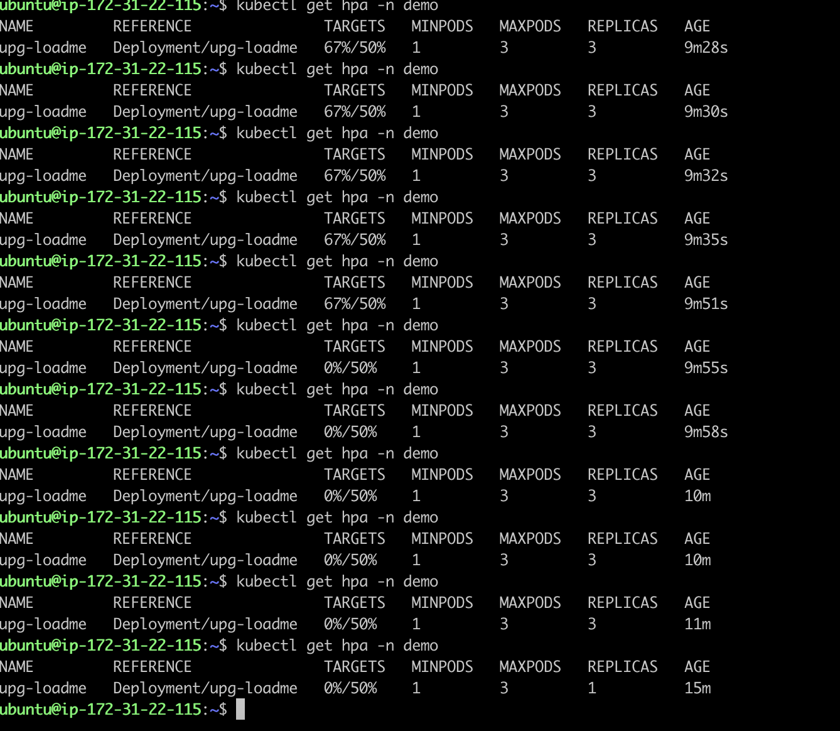

**Metrics usage increasing with load**

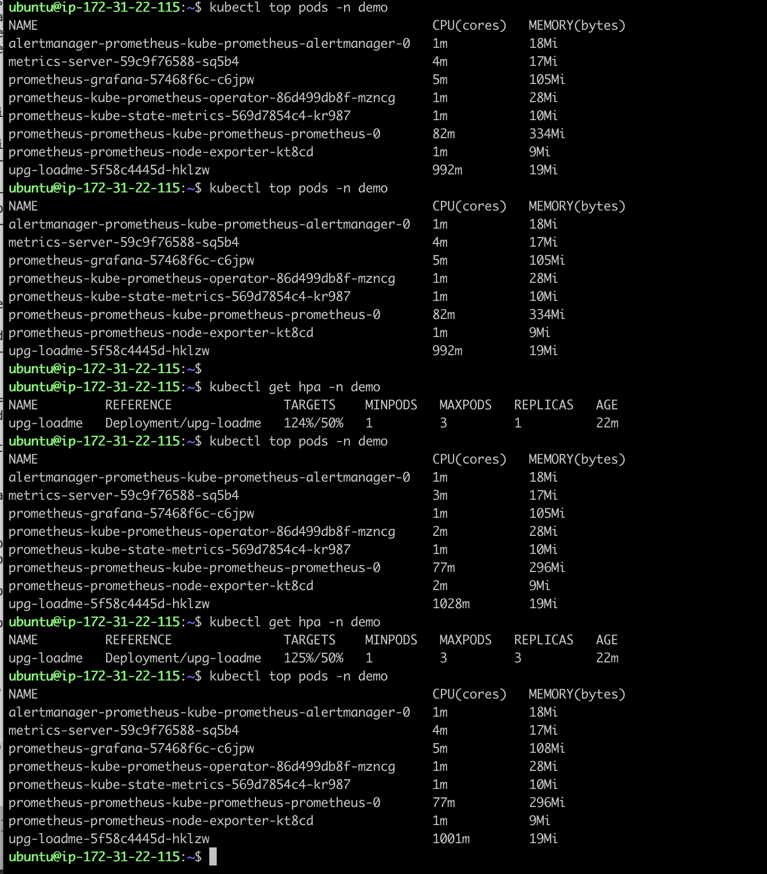

**All objects in demo namespace**

